Phase 2

webMethods ActiveTransfer: Advanced Configuration and Management

**Table of Abbrevations**

|  |  |
| --- | --- |
| **Abbreviation** | **Full Form** |

|  |  |
| --- | --- |
| API | Application Programming Interface |

|  |  |
| --- | --- |
| ES Module | ECMAScript Modules |

|  |  |
| --- | --- |
| HEC | HTTP Event Collector |

|  |  |
| --- | --- |
| ICAP | Internet Content Adaptation Protocol |

|  |  |
| --- | --- |
| JVM | Java Virtual Machine |

|  |  |
| --- | --- |
| POC | Proof of Concept |

|  |  |
| --- | --- |
| SFTP | SSH File Transfer Protocol |

|  |  |
| --- | --- |
| DMZ | Demilitarized Zone |

|  |  |
| --- | --- |
| ERP | Enterprise Resource Planning |

|  |  |
| --- | --- |
| CRM | Customer Relationship Management |

|  |  |
| --- | --- |
| HTTP | Hypertext Transfer Protocol |

|  |  |
| --- | --- |
| FTP | File Transfer Protocol |

|  |  |
| --- | --- |
| XML | Extensible Markup Language |

|  |  |
| --- | --- |
| JSON | JavaScript Object Notation |

|  |  |
| --- | --- |
| API | Application Programming Interface |

|  |  |
| --- | --- |
| JVM | Java Virtual Machine |

|  |  |
| --- | --- |
| RESTful | Representational State Transfer |

|  |  |
| --- | --- |
| SDK | Software Development Kit |

|  |  |
| --- | --- |
| UI | User Interface |

**Chapter 1: Data Protection Rules**

**Q1. What are all necessary Data Protection rules region/country wise?**

Data protection rules vary by region and country, with each jurisdiction imposing specific regulations to safeguard personal data. Below is a summary of key data protection rules across different regions:

1. European Union (EU) - GDPR:

Principles: Lawfulness, fairness, transparency, purpose limitation, data minimization, accuracy, storage limitation, integrity, and confidentiality.

Rights: Right to access, rectification, erasure, restriction of processing, data portability, and objection.

Obligations: Data protection impact assessments (DPIAs), breach notifications, and appointing a Data Protection Officer (DPO).

1. United States:

Federal Laws: Health Insurance Portability and Accountability Act (HIPAA), Gramm-Leach-Bliley Act (GLBA), and Children's Online Privacy Protection Act (COPPA).

State Laws: California Consumer Privacy Act (CCPA), New York SHIELD Act.

1. Asia-Pacific:

Australia: Privacy Act 1988 and Australian Privacy Principles (APPs).

Singapore: Personal Data Protection Act (PDPA).

India: Personal Data Protection Bill (PDPB).

1. Latin America:

Brazil: General Data Protection Law (LGPD).

Steps to Ensure Compliance:

* Understand Local Regulations: Familiarize yourself with the data protection laws relevant to your operations.
* Implement Data Protection Policies: Develop and enforce data protection policies that comply with local regulations.
* Appoint a DPO: If required, appoint a Data Protection Officer to oversee compliance.
* Conduct DPIAs: Regularly perform Data Protection Impact Assessments to identify and mitigate risks.
* Train Employees: Provide ongoing training to employees on data protection best practices.

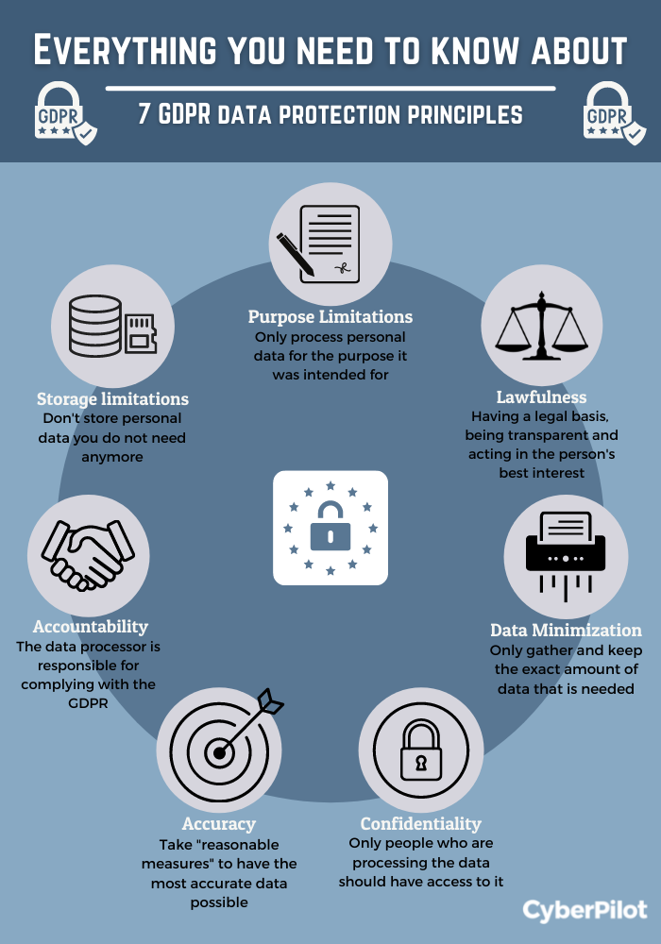

**Chapter 2: Preparing to Work with the ActiveTransfer Web Client**

**Introduction**

Working with the ActiveTransfer Web Client is crucial for managing and securing file transfers within an organization. This chapter will guide you through the preparation steps, ensuring you are ready to utilize the ActiveTransfer Web Client effectively.

**Understanding the Basics of ActiveTransfer**

What is ActiveTransfer?

ActiveTransfer is a Managed File Transfer (MFT) solution from Software AG's webMethods suite. It facilitates the secure and reliable transfer of files between systems, partners, and users.

**Key Features**

* **Secure File Transfer:** Ensures data is transferred securely using various protocols.
* **Automation:** Automates file transfer processes to enhance efficiency.
* **Monitoring and Logging:** Provides tools for monitoring and logging file transfer activities.
* **Integration:** Seamlessly integrates with other webMethods products.

**System Requirements**

**Ensure System Compatibility**

Verify that your system meets the hardware and software requirements specified by Software AG for running ActiveTransfer.

**Web Browser Compatibility**

Ensure the web browser you plan to use is supported by ActiveTransfer Web Client. Commonly supported browsers include Google Chrome, Mozilla Firefox, Microsoft Edge, and Safari.

**Network and Security Configuration**

**Network Configuration**

* Ensure your network allows access to the ActiveTransfer Web Client URL.
* Configure firewalls to permit traffic on the necessary ports.

**Security Settings**

* Ensure SSL/TLS certificates are properly configured for secure connections.
* Verify that appropriate security measures, such as VPNs or secure tunnels, are in place if accessing ActiveTransfer from outside your organization's network.

**User Accounts and Permissions**

**User Account Setup**

* Ensure users have the necessary credentials to log into the ActiveTransfer Web Client.
* Set up user accounts in the ActiveTransfer server with the appropriate roles and permissions.

**Role-Based Access Control (RBAC)**

* Understand and assign roles such as Administrator, Operator, and User, depending on the level of access required.

**Familiarizing with the Interface**

**Login and Navigation**

* Learn how to log in and navigate through the ActiveTransfer Web Client interface.
* Familiarize yourself with the main dashboard, which provides an overview of recent activities and statuses.

**Menu and Options**

* Explore the various menus and options available, such as Transfers, Reports, and Configuration settings.

**File Transfer Basics**

**Uploading and Downloading Files**

* Practice basic file transfer operations like uploading and downloading files.
* Learn how to use features like drag-and-drop for ease of use.

**Transfer Protocols**

* Understand the different transfer protocols supported, such as FTP, SFTP, FTPS, and HTTP/S.

**Automating File Transfers**

**Scheduling Transfers**

* Learn how to create and manage scheduled file transfers.
* Understand the importance of timing and frequency in scheduled transfers.

**Triggers and Actions**

* Explore how to set up triggers (e.g., file arrival) and actions (e.g., move or copy file) to automate processes.

**Monitoring and Reporting**

**Real-Time Monitoring**

* Use the monitoring tools to track ongoing file transfers and check their statuses in real-time.

**Logs and Reports**

* Learn how to generate and interpret logs and reports for auditing and troubleshooting purposes.

**Troubleshooting and Support**

**Common Issues**

* Be aware of common issues like connection failures, transfer interruptions, and permission errors.

**Support Resources**

* Know where to find help, such as online documentation, community forums, and contacting Software AG support.

**Best Practices**

**Security Best Practices**

* Regularly update your software to the latest version to ensure security patches are applied.
* Use strong passwords and enable multi-factor authentication (MFA) for user accounts.

**Operational Best Practices**

* Regularly monitor your system and file transfer activities.
* Maintain clear documentation of your configurations and processes.

**Proof of Concept (PoC) Steps**

**Step 1: Setting Up a Test Environment**

1. **Install ActiveTransfer Server:**
   * Follow the installation guide provided by Software AG to set up the ActiveTransfer server in a test environment.
2. **Create User Accounts:**
   * Create test user accounts with different roles to understand the access control mechanisms.
3. **Configure Security Settings:**
   * Set up SSL/TLS certificates and configure the firewall to allow necessary traffic.

**Step 2: Performing Basic File Transfers**

1. **Login to ActiveTransfer Web Client:**
   * Use the credentials of the test user accounts to log in.
2. **Upload and Download Files:**
   * Practice uploading and downloading files using different transfer protocols (FTP, SFTP, FTPS, HTTP/S).

**Step 3: Automating Transfers**

1. **Schedule Transfers:**
   * Create and manage scheduled file transfers, testing different timing and frequency settings.
2. **Set Up Triggers and Actions:**
   * Configure triggers and actions to automate file transfers and monitor the outcomes.

**Step 4: Monitoring and Reporting**

1. **Real-Time Monitoring:**
   * Use the monitoring tools to observe file transfer activities in real-time.
2. **Generate Reports:**
   * Generate and review logs and reports to understand the transfer activities and troubleshoot any issues.

**Chapter 3: Integrating webMethods ActiveTransfer with Azure Active Directory (On-Premise Version)**

**Introduction**

Integrating webMethods ActiveTransfer with Azure Active Directory (AD) centralizes user management, enhances security, and streamlines file transfer processes. This comprehensive guide will take you through the steps to integrate Active Directory with webMethods ActiveTransfer, ensuring smooth user authentication, management, and monitoring. This version focuses on the on-premise setup of webMethods ActiveTransfer.

**Part 1: Preparing for Integration**

**Prerequisites**

Before you begin, ensure the following:

* You have administrative access to both webMethods ActiveTransfer and Azure AD.
* The webMethods ActiveTransfer username must match the Principal Name in Azure AD.
* The Active toggle button must be enabled in the Azure AD settings to avoid login failures.

**Part 2: Configuring LDAP with Azure AD using Azure AD Domain Services**

**Step-by-Step Integration**

**Step 1: Log in to webMethods Integration Server**

1. **Log in to webMethods Integration Server**
   * Open your browser and go to the webMethods Integration Server login page.
   * Enter your credentials and log in.

**Step 2: Navigate to Common Directory Services**

1. **Navigate to Common Directory Services**
   * Select **Settings** > **Common Directory Services**.
   * This action will redirect you to another tab.

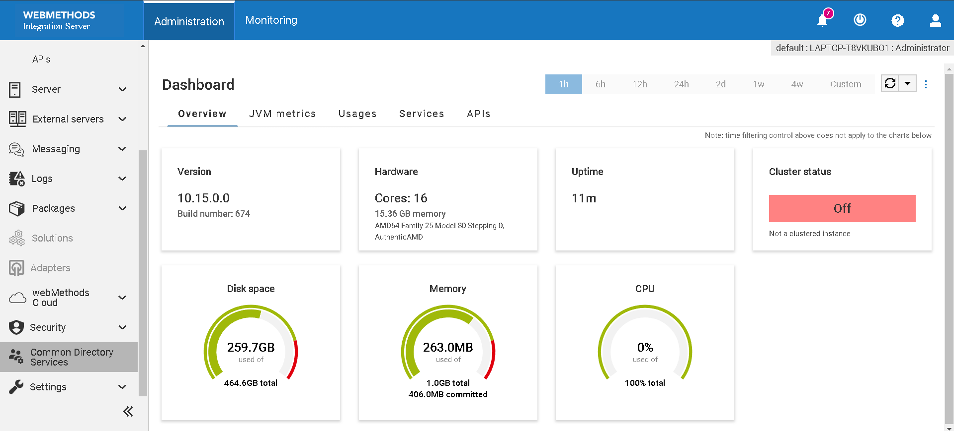

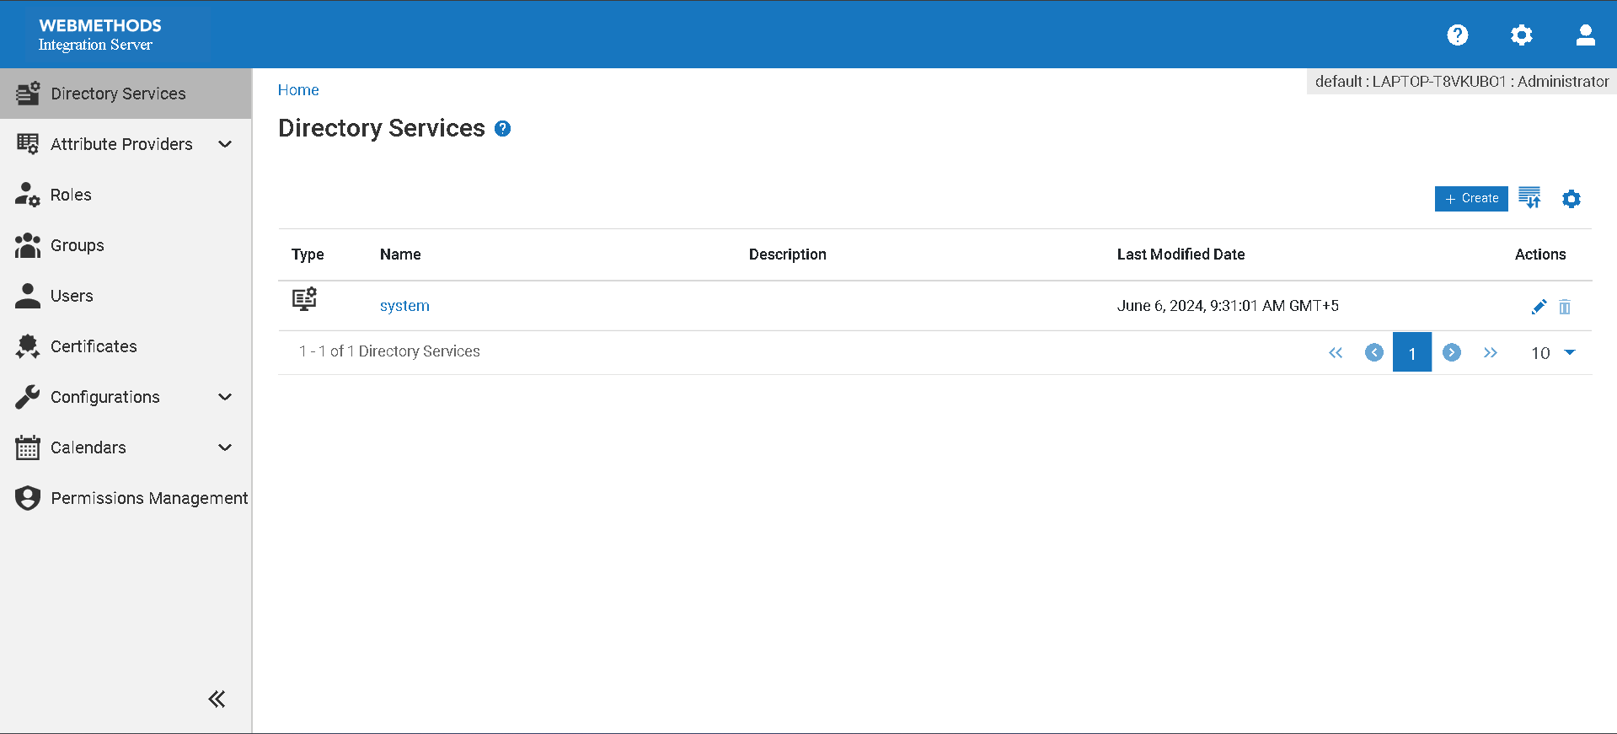

**Step 3: Create a Directory**

1. **Create a Directory**
   * Click on **Create Directory**.

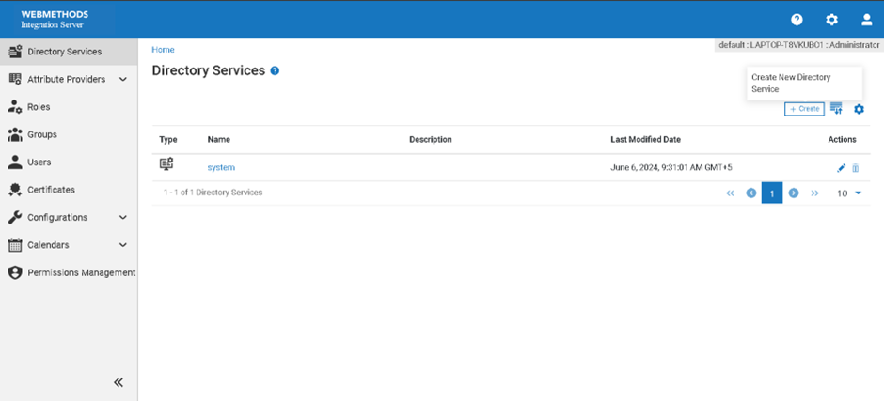

* + In the directory type, select **LDAP**.

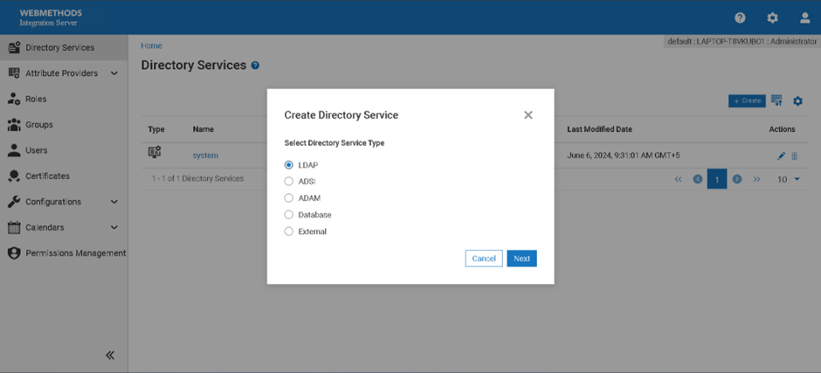

**Step 4: Enter Directory Details**

1. **Enter Directory Details**
   * Provide a suitable name for the directory.

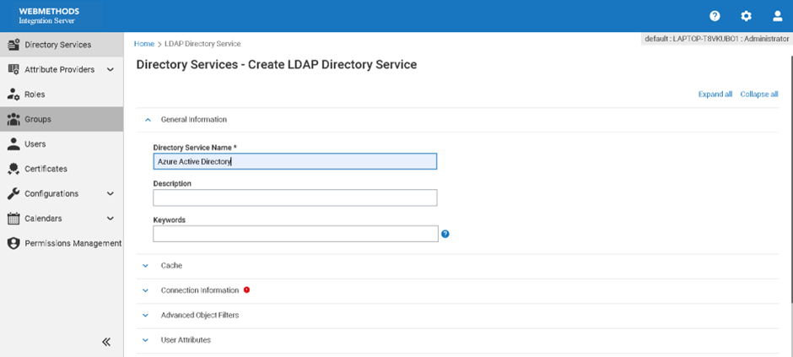

* + Fill in all necessary fields, such as "Provider URL," "BaseDN," and "Security Principal."
  + Make sure all required information from your Azure AD Domain Services is correctly entered.

**Step 5: Save Configuration**

1. **Save Configuration**
   * Once all fields are correctly filled out, click **Save** to complete the configuration.

**Step 6: Verification**

1. **Verification**
   * Ensure the newly created directory appears in the list of directories.
   * Verify the connection by testing it within the interface.

**Part 3: Enabling LDAP in Azure AD**

**Step-by-Step Integration**

**Step 1: Enable Azure AD Domain Services**

1. **Log in to Azure Portal**
   * Open your browser and navigate to the [Azure portal](https://portal.azure.com/).
   * Enter your administrative credentials to log in.
2. **Create a New Azure AD Domain Services Instance**
   * Navigate to **Create a resource** > **Azure AD Domain Services**.
   * Click **Create** and provide the necessary details, such as DNS domain name, resource group, and virtual network.
3. **Configure LDAP over SSL**
   * Once the instance is created, navigate to the **Azure AD Domain Services** blade.
   * Go to **Settings** > **Secure LDAP**.
   * Enable **Secure LDAP (LDAPS)** and, if needed, configure the public endpoint for LDAPS access.
   * Save the changes.
4. **Download the LDAPS Certificate**
   * Download the public LDAPS certificate from the Azure AD Domain Services instance to trust it in your applications.

**Step 2: Configure Azure AD Domain Services**

1. **Update DNS Settings**
   * Ensure the virtual network's DNS settings point to the Azure AD Domain Services IP addresses.
2. **Enable User Account Synchronization**
   * Navigate to **Azure AD Domain Services** > **Settings** > **User settings**.
   * Enable password hash synchronization and configure password synchronization settings.

**Step 3: Register webMethods ActiveTransfer in Azure Console**

1. **Log in to Azure Console**
   * Open your browser and navigate to the [Azure portal](https://portal.azure.com/).
   * Enter your administrative credentials to log in.
2. **Register webMethods ActiveTransfer as a New Application**
   * In the Azure portal, navigate to **Azure Active Directory** > **App registrations**.

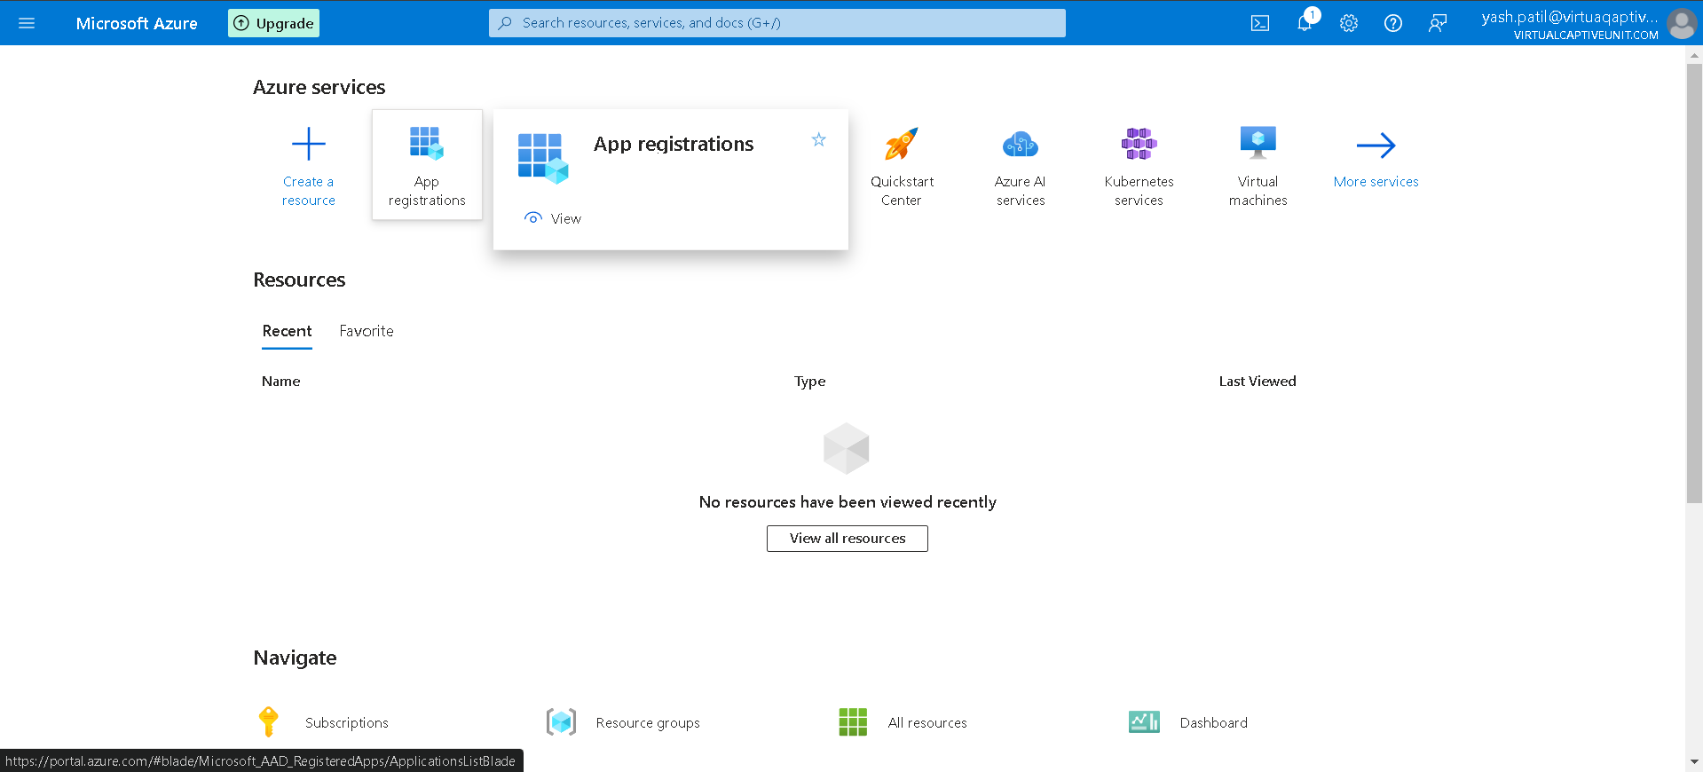

* + Click on **New registration**.

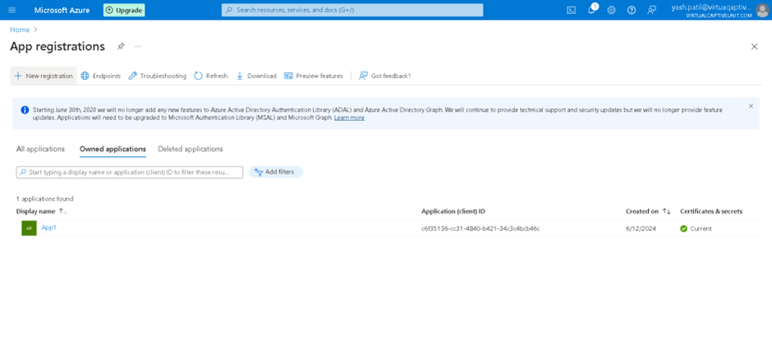

* + - **Name:** Enter a meaningful name for the application (e.g., "webMethods ActiveTransfer").
    - **Supported account types:** Select "Accounts in this organizational directory only" to restrict access to users within your organization.

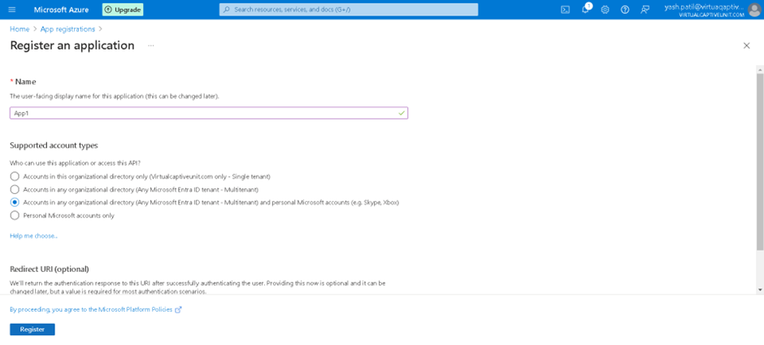

* + Click **Register** to create the application.

1. **Copy Application Details**
   * After the application is registered, navigate to the application's **Overview** page.
   * Copy the following details:
     + **Application (client) ID:** This is your application's unique identifier.
     + **Directory (tenant) ID:** This ID identifies your Azure AD tenant.

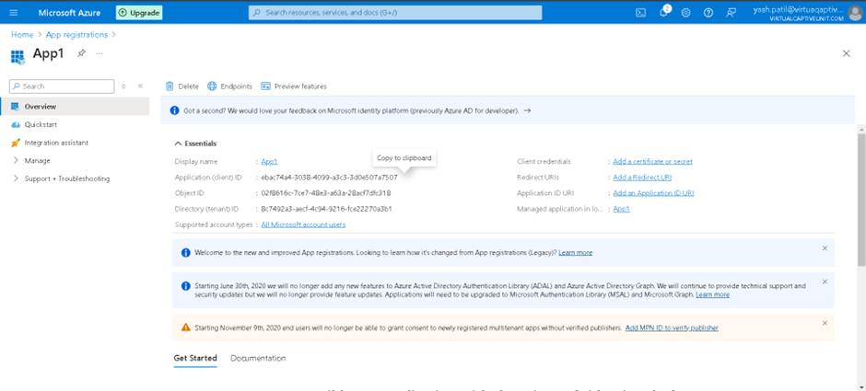

* + Go to the **Certificates & secrets** section and create a new client secret.
    - **Client Secret:** Copy this value as it will be used for authentication.
  + Note down the **Configuration URL**:
    - Navigate to **Endpoints** under **Overview** and copy the **OAuth 2.0 authorization endpoint** URL.

**Part 4: Detailed Steps for Integrating Active Directory with webMethods ActiveTransfer**

**Introduction**

Integrating Active Directory (AD) with webMethods ActiveTransfer centralizes user management, enhances security, and simplifies administrative tasks. This guide provides a step-by-step process to integrate AD with ActiveTransfer, ensuring smooth user authentication, management, and monitoring.

**Actions Performed Using Active Directory in webMethods ActiveTransfer**

**User Authentication**

**Enable Single Sign-On (SSO)**

1. **Log in to the ActiveTransfer Administration Console**
   * Access the console using your admin credentials.
2. **Navigate to Security Settings**
   * Go to the "Security Settings" section where SSO options are available.
3. **Configure SSO Settings**
   * Enter the AD domain and server details.
   * Enable SSO and save the settings.
   * Test the SSO configuration by logging in with AD credentials to ensure it works correctly.

**Define Authentication Policies**

1. **Access Authentication Policies**
   * Go to the "Security Settings" and find the "Authentication Policies" section.
2. **Set Up Policies**
   * Define password policies such as complexity requirements and expiration.
   * Configure account lockout policies to specify the number of failed login attempts before an account is locked.
3. **Apply Policies**
   * Save and apply the authentication policies to enforce them across all AD-integrated users.

**User and Group Management**

**Import Users and Groups**

1. **Navigate to User Management**
   * Go to the "User Management" section in the ActiveTransfer console.
2. **Initiate Import**
   * Select the option to import users and groups from Active Directory.
   * Provide the necessary AD details (e.g., domain name, server address).
3. **Select Users and Groups**
   * Choose the specific users and groups you want to import.
   * Start the import process and verify that the users and groups appear in the ActiveTransfer user list.

**Assign Roles**

1. **Access Role Management**
   * Go to the "Roles and Permissions" section.
2. **Assign Roles to Imported Users**
   * Select the imported users or groups.
   * Assign appropriate roles based on their responsibilities.
   * Save the role assignments.

**Automatic Synchronization**

1. **Enable Synchronization**
   * In the "User Management" section, find the synchronization settings.
2. **Configure Sync Frequency**
   * Set up automatic synchronization intervals (e.g., daily, weekly).
   * Ensure that any changes in AD (new users, deleted users) are reflected in ActiveTransfer.
3. **Test Synchronization**
   * Perform a test sync to verify that the settings are working correctly.

**Access Control**

**Implement Role-Based Access Control (RBAC)**

1. **Define Roles**
   * Go to the "Role Management" section and create roles based on job functions.
2. **Assign Permissions**
   * For each role, define specific permissions for accessing files, folders, and transfer operations.
3. **Apply RBAC**
   * Assign these roles to users and groups imported from AD.
   * Save the configurations and verify that access control is correctly applied.

**Security Policies**

**Enforce Password Policies**

1. **Access Password Policy Settings**
   * Navigate to the "Security Settings" and find the "Password Policy" section.
2. **Define Policies**
   * Set complexity requirements (e.g., minimum length, special characters).
   * Specify password expiration periods.
3. **Apply Policies**
   * Save the password policies to enforce them for all AD users.

**Implement Account Lockout Policies**

1. **Access Account Lockout Settings**
   * Go to the "Security Settings" and find the "Account Lockout Policy" section.
2. **Set Lockout Thresholds**
   * Define the number of failed login attempts before an account is locked.
   * Specify the lockout duration.
3. **Apply Policies**
   * Save the lockout policies to protect against unauthorized access attempts.

**Monitoring and Auditing**

**Monitor User Activities**

1. **Enable Activity Logging**
   * Go to the "Monitoring" section and enable activity logging.
2. **Track Activities**
   * Configure the system to log user login attempts, file transfers, and other actions.
3. **Review Logs**
   * Regularly review activity logs to detect any unusual or unauthorized activities.

**Maintain Audit Trails**

1. **Enable Auditing**
   * In the "Monitoring" section, enable audit logging for compliance purposes.
2. **Configure Audit Settings**
   * Define what activities to audit (e.g., data access, administrative changes).
3. **Review Audit Trails**
   * Periodically review audit trails to ensure all user actions are properly recorded and traceable.

**Proof of Concept (PoC) Steps**

**Step 1: Setting Up a Test Environment**

1. **Install Active Directory**
   * Set up an AD instance in a test environment.
2. **Create Test Users and Groups**
   * Create a few test users and groups in AD.

**Step 2: Configuring ActiveTransfer for AD Integration**

1. **Access ActiveTransfer Console**
   * Log in to the ActiveTransfer administration console in your test environment.
2. **Configure AD Settings**
   * Enter the AD details and test the connection to ensure successful integration.

**Step 3: Import and Manage Users**

1. **Import Test Users**
   * Import the test users and groups from AD into ActiveTransfer.
2. **Assign Roles**
   * Assign roles and permissions to the imported test users and groups.

**Step 4: Test Authentication and Access Control**

1. **Test SSO**
   * Verify that test users can log in using their AD credentials.
2. **Check Access Control**
   * Ensure that access controls and permissions are correctly applied based on AD roles.

**Step 5: Monitor and Audit Activities**

1. **Monitor User Activities**
   * Track login attempts and file transfers of test users.
2. **Audit Logs**
   * Review audit logs to ensure all activities are logged and traceable.

**Chapter 4: Managing Folders and Files in the ActiveTransfer Web Client**

**Introduction**

The ActiveTransfer Web Client provides a comprehensive interface for managing folders and files, facilitating secure and efficient file transfers. This chapter outlines the various tasks you can perform with folders and files, ensuring you have the knowledge to utilize the platform effectively.

**Overview of the ActiveTransfer Web Client Interface**

Before diving into the specific tasks, it’s important to understand the layout and features of the ActiveTransfer Web Client interface. The interface typically includes sections for navigation, file and folder management, transfer monitoring, and configuration settings.

**Tasks Performed with Folders**

**Creating Folders**

Creating folders is fundamental for organizing files and managing file transfers.

1. **Navigate to the Desired Location:**
   * Use the navigation pane to go to the directory where you want to create a new folder.
2. **Create Folder:**
   * Click on the "New Folder" button or right-click and select "New Folder."
   * Enter the name of the new folder and confirm.

**Renaming Folders**

Renaming folders helps in maintaining clarity and organization.

1. **Select the Folder:**
   * Navigate to the folder you want to rename.
2. **Rename Folder:**
   * Right-click on the folder and select "Rename."
   * Enter the new name and press Enter to save changes.

**Moving Folders**

Moving folders allows you to restructure your file organization.

1. **Select the Folder:**
   * Navigate to the folder you want to move.
2. **Move Folder:**
   * Right-click and select "Move" or drag-and-drop the folder to the desired location.

**Deleting Folders**

Deleting folders helps in managing storage and removing unnecessary data.

1. **Select the Folder:**
   * Navigate to the folder you want to delete.
2. **Delete Folder:**
   * Right-click and select "Delete."
   * Confirm the deletion.

**Setting Folder Permissions**

Managing folder permissions is crucial for controlling access and maintaining security.

1. **Select the Folder:**
   * Navigate to the folder for which you want to set permissions.
2. **Set Permissions:**
   * Right-click and select "Properties" or "Permissions."
   * Define the access permissions for users and groups.

**Tasks Performed with Files**

**Uploading Files**

Uploading files is a primary task in file transfer operations.

1. **Navigate to the Target Folder:**
   * Go to the folder where you want to upload files.
2. **Upload Files:**
   * Click on the "Upload" button or drag-and-drop files into the folder.
   * Select files from your local system and confirm the upload.

**Downloading Files**

Downloading files allows you to retrieve files from the server to your local system.

1. **Select the File:**
   * Navigate to the file you want to download.
2. **Download File:**
   * Right-click and select "Download" or use the download button.
   * Choose the destination on your local system and confirm.

**Renaming Files**

Renaming files helps in maintaining proper file naming conventions and clarity.

1. **Select the File:**
   * Navigate to the file you want to rename.
2. **Rename File:**
   * Right-click and select "Rename."
   * Enter the new name and press Enter to save changes.

**Moving Files**

Moving files is essential for organizing and managing file locations.

1. **Select the File:**
   * Navigate to the file you want to move.
2. **Move File:**
   * Right-click and select "Move" or drag-and-drop the file to the desired location.

**Deleting Files**

Deleting files is necessary for managing storage space and removing obsolete data.

1. **Select the File:**
   * Navigate to the file you want to delete.
2. **Delete File:**
   * Right-click and select "Delete."
   * Confirm the deletion.

**Viewing File Details**

Viewing file details provides information about the file, such as size, type, and modification date.

1. **Select the File:**
   * Navigate to the file you want to view details for.
2. **View Details:**
   * Right-click and select "Properties" or "Details."
   * Review the file information in the properties window.

**Setting File Permissions**

Setting file permissions is vital for controlling access to specific files.

1. **Select the File:**
   * Navigate to the file for which you want to set permissions.
2. **Set Permissions:**
   * Right-click and select "Properties" or "Permissions."
   * Define the access permissions for users and groups.

**Advanced File and Folder Management Tasks**

**Synchronizing Folders**

Synchronizing folders ensures that the contents of folders on different systems are identical.

1. **Select the Source Folder:**
   * Navigate to the folder you want to synchronize.
2. **Synchronize Folder:**
   * Right-click and select "Synchronize."
   * Choose the target location and set synchronization options.

**Compressing and Extracting Files**

Compressing files reduces their size for transfer, and extracting allows you to access compressed content.

1. **Compress Files:**
   * Select the files you want to compress.
   * Right-click and select "Compress" or "Zip."
   * Define the archive name and location.
2. **Extract Files:**
   * Select the compressed file (e.g., ZIP).
   * Right-click and select "Extract."
   * Choose the extraction location and confirm.

**Monitoring File Transfers**

Monitoring file transfers ensures that you can track the progress and status of your transfers.

1. **Access Transfer Monitor:**
   * Navigate to the transfer monitoring section of the ActiveTransfer Web Client.
2. **Monitor Transfers:**
   * Review the list of ongoing, completed, and failed transfers.
   * Check transfer details and logs for more information.

**Proof of Concept (PoC) Steps**

**Step 1: Setting Up a Test Environment**

1. **Install ActiveTransfer Server:**
   * Follow the installation guide provided by Software AG to set up the ActiveTransfer server in a test environment.
2. **Create Test Folders and Files:**
   * Set up a few test folders and files to practice managing them within the ActiveTransfer Web Client.

**Step 2: Performing Basic Folder Tasks**

1. **Create and Rename Folders:**
   * Practice creating and renaming folders.
2. **Move and Delete Folders:**
   * Test moving and deleting folders to understand the process.
3. **Set Folder Permissions:**
   * Configure permissions for test folders.

**Step 3: Performing Basic File Tasks**

1. **Upload and Download Files:**
   * Upload files to test folders and download them back to your local system.
2. **Rename and Move Files:**
   * Rename and move files between folders.
3. **Delete Files:**
   * Practice deleting files and confirming their removal.
4. **View File Details and Set Permissions:**
   * Check file details and set permissions for test files.

**Step 4: Advanced Tasks and Monitoring**

1. **Synchronize Folders:**
   * Test folder synchronization between different locations.
2. **Compress and Extract Files:**
   * Compress multiple files into a single archive and extract them back.
3. **Monitor File Transfers:**
   * Use the transfer monitoring tools to track the status of your file transfers.

**Chapter 5: Sharing Files and Folders Using the ActiveTransfer Web Client**

**Introduction**

Sharing files and folders is a crucial feature of the ActiveTransfer Web Client, allowing users to collaborate efficiently and securely. This chapter will guide you through the steps to share files and folders, ensuring you understand the different methods and options available.

**Overview of File and Folder Sharing**

The ActiveTransfer Web Client offers multiple ways to share files and folders, each designed to cater to different needs and security requirements. Users can share files and folders with internal team members or external partners, ensuring that the right people have access to the necessary resources.

**Methods of Sharing Files and Folders**

**Direct Sharing via Web Client**

Direct sharing involves providing access to files and folders through the ActiveTransfer Web Client interface.

1. **Login to the ActiveTransfer Web Client:**
   * Open the ActiveTransfer Web Client and log in with your credentials.
2. **Navigate to the File or Folder:**
   * Use the navigation pane to locate the file or folder you want to share.
3. **Select the File or Folder:**
   * Click on the file or folder to select it.
4. **Initiate Sharing:**
   * Right-click on the selected file or folder and choose the "Share" option.
   * Alternatively, click on the "Share" button in the toolbar.
5. **Configure Sharing Options:**
   * Enter the email addresses of the recipients you want to share with.
   * Set permissions (e.g., read-only, read-write) for each recipient.
   * Add an optional message to provide context or instructions.
6. **Send Share Link:**
   * Click "Send" to share the file or folder.
   * Recipients will receive an email with a link to access the shared file or folder.

**Creating Public Links**

Public links allow users to share files and folders with a broader audience, including individuals who may not have an ActiveTransfer account.

1. **Login to the ActiveTransfer Web Client:**
   * Open the ActiveTransfer Web Client and log in with your credentials.
2. **Navigate to the File or Folder:**
   * Use the navigation pane to locate the file or folder you want to share.
3. **Select the File or Folder:**
   * Click on the file or folder to select it.
4. **Initiate Public Link Creation:**
   * Right-click on the selected file or folder and choose the "Create Public Link" option.
   * Alternatively, click on the "Create Public Link" button in the toolbar.
5. **Configure Link Settings:**
   * Set expiration date for the link to control how long it remains active.
   * Enable or disable download permissions for recipients.
   * Optionally, set a password to add an extra layer of security.
6. **Generate Link:**
   * Click "Generate" to create the public link.
   * Copy the link and share it with the intended audience via email or any other communication method.

**Using Shared Workspaces**

Shared workspaces allow multiple users to collaborate on a set of files and folders within a designated area.

1. **Create a Shared Workspace:**
   * Navigate to the "Workspaces" section in the ActiveTransfer Web Client.
   * Click on "New Workspace" and enter a name and description for the workspace.
2. **Add Files and Folders:**
   * Upload or move files and folders into the shared workspace.
3. **Invite Users:**
   * Click on "Invite Users" and enter the email addresses of the users you want to invite.
   * Assign appropriate roles and permissions to each user (e.g., Viewer, Editor).
4. **Collaborate:**
   * Users can access the shared workspace, upload new files, and edit existing ones based on their permissions.
   * Use the workspace's communication tools to discuss and collaborate on files.

**Chapter 6: Server Configuration Parameters and Variables in webMethods ActiveTransfer**

Effective server configuration is essential for ensuring that webMethods ActiveTransfer operates efficiently and securely. This chapter provides a comprehensive overview of the various server configuration parameters and variables available in ActiveTransfer. Understanding these settings will help you tailor the system to meet your specific needs and optimize its performance.

**Overview of Server Configuration**

Server configuration parameters and variables in ActiveTransfer control various aspects of the server's behavior, including security settings, performance tuning, and connection management. These configurations can be adjusted through the ActiveTransfer Administration interface or by directly editing configuration files.

**Key Server Configuration Parameters and Variables**

**1. General Server Settings**

**Server Name**:

* **Description**: The name of the ActiveTransfer server.
* **Default Value**: ActiveTransfer Server
* **Usage**: Helps identify the server in a multi-server environment.

**Server Port**:

* **Description**: The port on which the ActiveTransfer server listens for incoming connections.
* **Default Value**: 8080
* **Usage**: Ensure this port is open and not used by other applications.

**Maximum Concurrent Sessions**:

* **Description**: The maximum number of concurrent user sessions allowed.
* **Default Value**: 100
* **Usage**: Increase this value for higher user concurrency requirements.

**2. Security Settings**

**SSL/TLS Configuration**:

* **Description**: Settings related to SSL/TLS for secure communications.
* **Parameters**:
  + keystoreFile: Path to the keystore file containing server certificates.
  + keystorePassword: Password for the keystore.
  + truststoreFile: Path to the truststore file.
  + truststorePassword: Password for the truststore.
* **Usage**: Configure to enable secure file transfers and server communications.

**Password Policy**:

* **Description**: Enforces password complexity and expiration policies.
* **Parameters**:
  + minLength: Minimum password length (e.g., 8).
  + requireSpecialChars: Whether special characters are required (e.g., true).
  + expirationDays: Number of days before password expiration (e.g., 90).
* **Usage**: Enhance security by enforcing strong password policies.

**IP Whitelisting**:

* **Description**: Restricts access to the server based on IP addresses.
* **Parameters**:
  + allowedIPs: List of allowed IP addresses (e.g., 192.168.1.1,192.168.1.2).
* **Usage**: Enhance security by limiting access to trusted IPs.

**3. File Transfer Settings**

**Transfer Buffer Size**:

* **Description**: Size of the buffer used during file transfers.
* **Default Value**: 8192 (8 KB)
* **Usage**: Adjust to optimize performance based on file sizes and network conditions.

**Retry Attempts**:

* **Description**: Number of times the server will retry a failed transfer.
* **Default Value**: 3
* **Usage**: Increase for unreliable network conditions to improve transfer success rates.

**Transfer Timeout**:

* **Description**: Maximum time allowed for a file transfer to complete.
* **Default Value**: 300 (seconds)
* **Usage**: Adjust based on network speed and file sizes.

**4. Logging and Monitoring**

**Log Level**:

* **Description**: Controls the verbosity of logs generated by the server.
* **Options**: ERROR, WARN, INFO, DEBUG
* **Default Value**: INFO
* **Usage**: Use DEBUG for troubleshooting, and INFO or WARN for normal operations.

**Log File Rotation**:

* **Description**: Configures log file rotation to manage disk space.
* **Parameters**:
  + maxFileSize: Maximum size of a log file before rotation (e.g., 10MB).
  + maxBackupFiles: Number of backup files to keep (e.g., 5).
* **Usage**: Ensure old logs are archived to prevent disk space issues.

**5. Connection Management**

**Idle Connection Timeout**:

* **Description**: Time after which idle connections are terminated.
* **Default Value**: 600 (seconds)
* **Usage**: Prevents resource wastage by terminating inactive sessions.

**Max Connections Per User**:

* **Description**: Maximum number of concurrent connections allowed per user.
* **Default Value**: 5
* **Usage**: Manage server load by limiting user connections.

**6. Advanced Settings**

**Thread Pool Size**:

* **Description**: Number of threads allocated for handling tasks.
* **Default Value**: 10
* **Usage**: Increase for high-load environments to improve performance.

**Cache Size**:

* **Description**: Size of the cache used for temporary storage of files.
* **Default Value**: 100MB
* **Usage**: Adjust based on available memory and file transfer volume.

**Database Connection Pool Size**:

* **Description**: Number of database connections maintained in the pool.
* **Default Value**: 20
* **Usage**: Increase for higher database query loads.

**Configuring Server Parameters**

**Accessing Configuration Files**

Server configuration parameters can be adjusted through the ActiveTransfer Administration interface or by editing the configuration files directly. Key configuration files include:

* **server.cnf**: Contains general server settings.
* **security.cnf**: Contains security-related settings.
* **transfer.cnf**: Contains file transfer-related settings.

**Editing Configuration Files**

1. **Locate Configuration Files**:
   * Access the directory where ActiveTransfer is installed.
   * Locate the configuration files in the config directory.
2. **Edit Configuration Files**:
   * Open the desired configuration file in a text editor.
   * Modify the parameters as needed.
   * Save the changes and restart the server for them to take effect.

**Using the Administration Interface**

1. **Log in to the Administration Interface**:
   * Access the ActiveTransfer Administration interface through a web browser.
2. **Navigate to Server Settings**:
   * Go to Integration Server > Server.
3. **Modify Parameters**:
   * Adjust the desired parameters directly through the interface.
   * Parameters that can be viewed or modified are Statistics, Licensing, Ports, Scheduling, Service Usage, Quiesce.

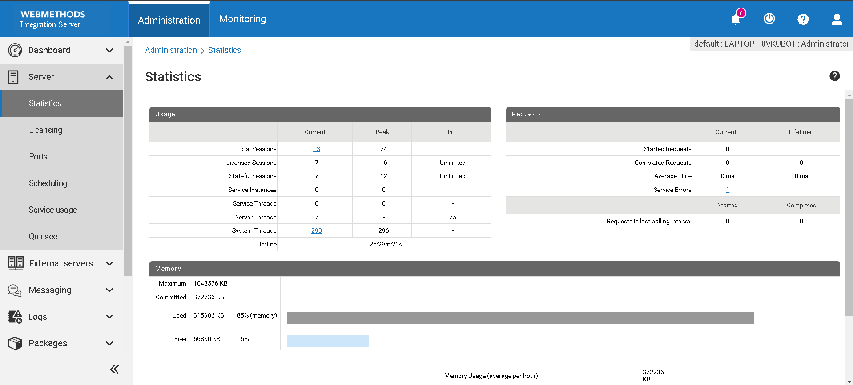

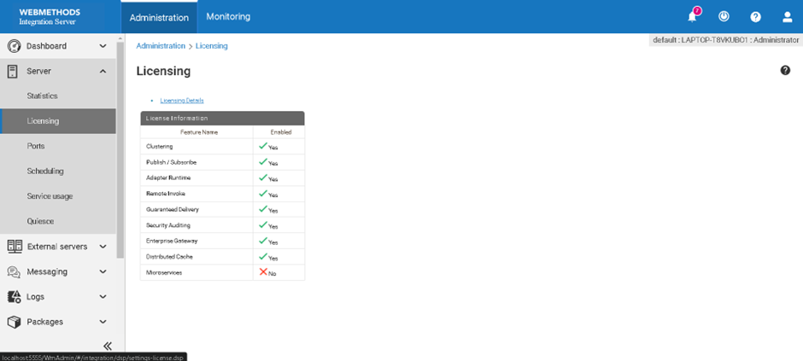

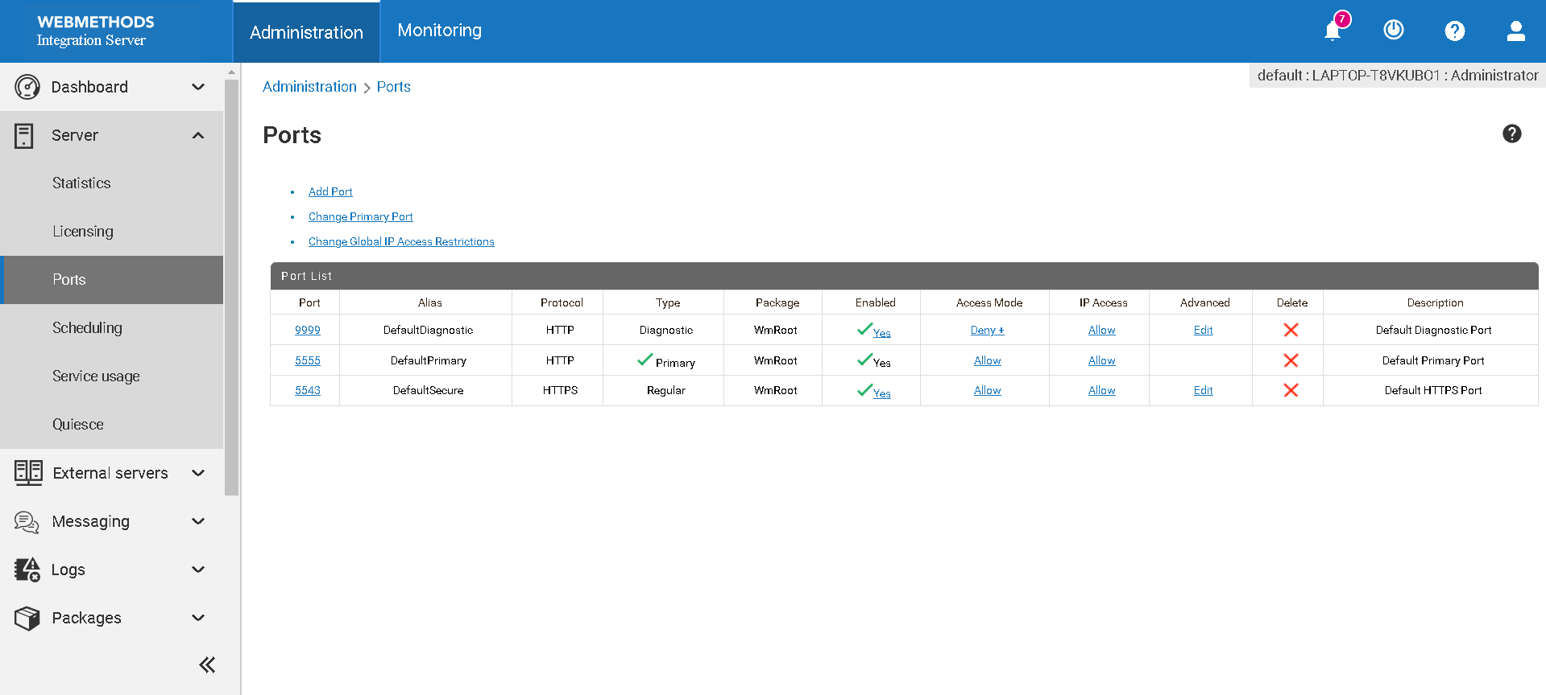

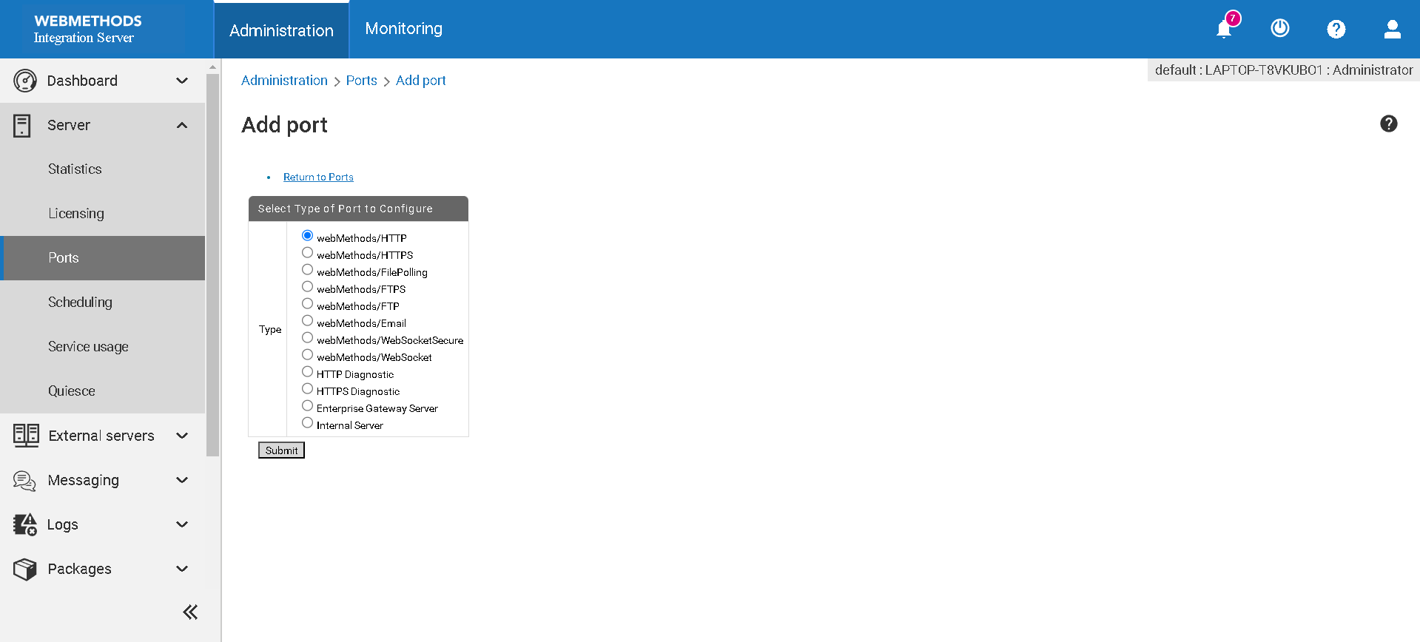

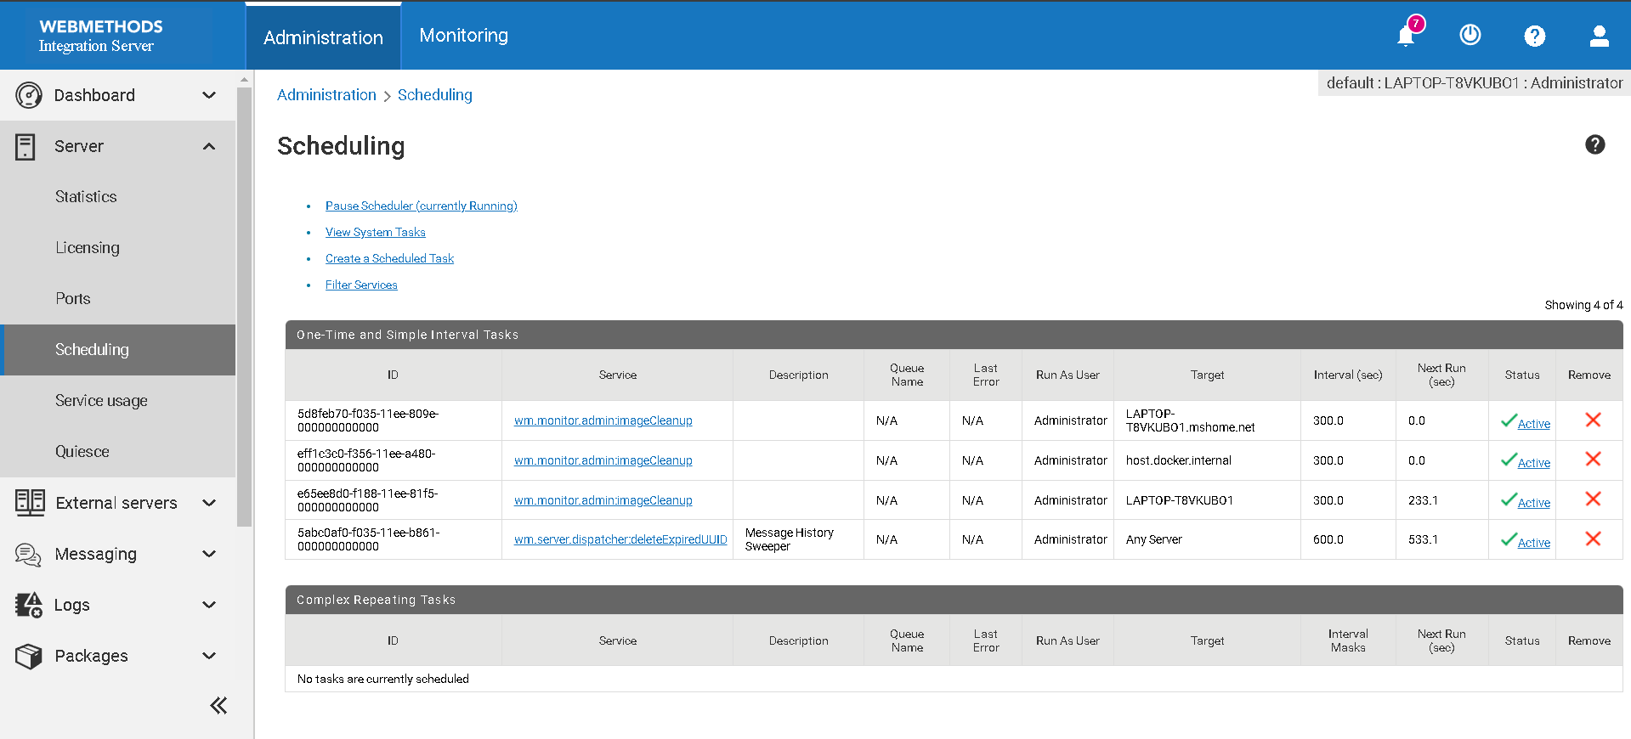

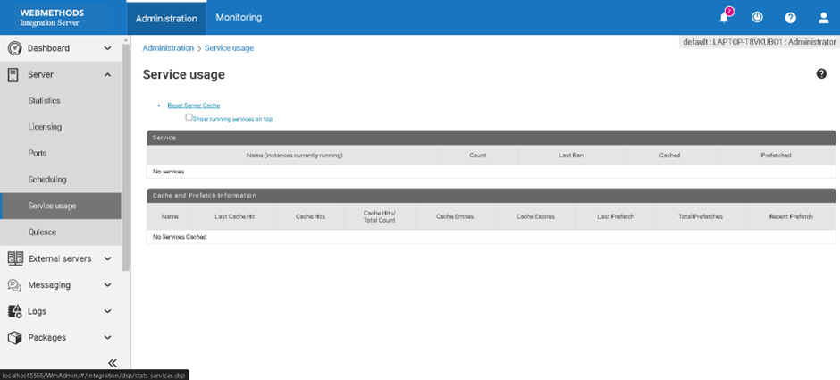

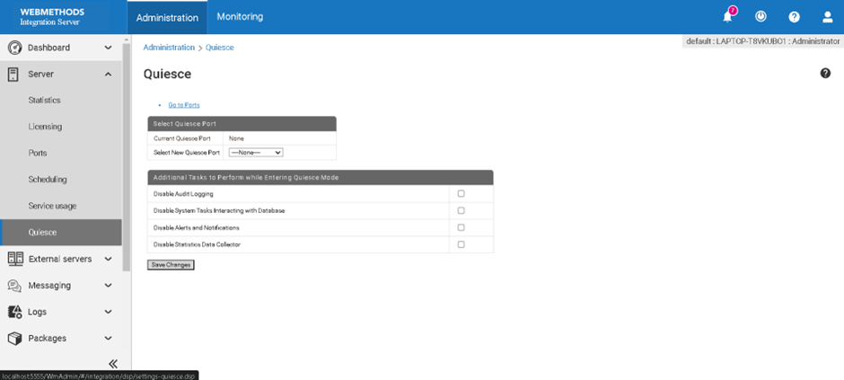

* + Save the changes to apply them immediately.

**Chapter 7: Configuring ActiveTransfer Gateway in webMethods ActiveTransfer**

ActiveTransfer Gateway is an essential component of webMethods ActiveTransfer, providing a secure means for external users to transfer files while protecting the internal network. This chapter will guide you through the process of configuring ActiveTransfer Gateway, ensuring secure and efficient file transfers.

**Introduction to ActiveTransfer Gateway**

ActiveTransfer Gateway serves as a secure proxy for file transfers, enabling external users to access the file transfer system without exposing the internal network. It supports various protocols such as FTP, FTPS, SFTP, and HTTP/S, and works in conjunction with the ActiveTransfer Server.

**Key Benefits of ActiveTransfer Gateway**

* **Security**: Isolates the internal network from external threats by acting as a proxy.
* **Performance**: Optimizes file transfer performance with minimal impact on internal resources.
* **Flexibility**: Supports multiple protocols and can be configured to meet various business needs.

**Configuration Process**

Configuring ActiveTransfer Gateway involves several steps, including installation, initial configuration, SSL/TLS setup, and integration with the ActiveTransfer Server. Follow these steps to configure ActiveTransfer Gateway effectively.

**Step 1: Installation**

1. **Download the Installation Package**:
   * Obtain the ActiveTransfer Gateway installation package from the Software AG Empower site or contact your Software AG representative.
2. **Run the Installer**:
   * Execute the installation package on the server where you want to install ActiveTransfer Gateway.
   * Follow the on-screen instructions to complete the installation.
3. **Verify Installation**:
   * Ensure the installation is successful by checking the installation logs and verifying the presence of the ActiveTransfer Gateway service.

**Step 2: Initial Configuration**

1. **Access the Configuration Files**:
   * Navigate to the installation directory of ActiveTransfer Gateway.
   * Locate the configuration files, typically found in the config directory.
2. **Edit Configuration Files**:
   * Open the primary configuration file (e.g., gateway.properties) in a text editor.
   * Configure basic settings such as server name, port, and logging levels.
   * Example configuration parameters:

properties

**gateway.name=ActiveTransferGateway**

**gateway.port=8022**

**gateway.log.level=INFO**

1. **Save and Apply Configuration**:
   * Save the changes and restart the ActiveTransfer Gateway service to apply the new settings.

**Step 3: Configure SSL/TLS**

1. **Generate or Obtain SSL Certificates**:
   * Obtain SSL certificates from a trusted Certificate Authority (CA) or generate self-signed certificates for testing purposes.
2. **Configure SSL/TLS in ActiveTransfer Gateway**:
   * Edit the SSL/TLS configuration settings in the gateway.properties file.
   * Example configuration:

properties

**ssl.enabled=true**

**ssl.keystore.path=/path/to/keystore.jks**

**ssl.keystore.password=changeit**

**ssl.truststore.path=/path/to/truststore.jks**

**ssl.truststore.password=changeit**

1. **Restart the Gateway**:
   * Restart the ActiveTransfer Gateway service to apply the SSL/TLS settings.

**Step 4: Integrate with ActiveTransfer Server**

1. **Access ActiveTransfer Administration**:
   * Log in to the ActiveTransfer Server administration interface.
2. **Configure Gateway Settings**:
   * Navigate to Solutions > ActiveTransfer > Administration > Gateway.
   * Add a new gateway configuration by providing details such as the gateway name, host, and port.
   * Example:
     + **Gateway Name**: MyActiveTransferGateway
     + **Host**: gateway.example.com
     + **Port**: 8022
3. **Enable Gateway**:
   * Enable the gateway in the ActiveTransfer Server configuration.
   * Ensure that the server can communicate with the gateway and that the gateway is operational.

**Step 5: Test the Configuration**

1. **Verify Connectivity**:
   * Test the connectivity between the ActiveTransfer Server and the ActiveTransfer Gateway.
   * Ensure that the gateway is reachable and that there are no network issues.
2. **Test File Transfers**:
   * Perform test file transfers using different protocols (FTP, FTPS, SFTP, HTTP/S) to ensure the gateway is functioning correctly.
   * Monitor the transfers for any errors or issues.
3. **Monitor Logs**:
   * Check the logs in both the ActiveTransfer Server and Gateway for any errors or warnings.
   * Ensure that the logs indicate successful transfers and no security breaches.

**Best Practices for Configuring ActiveTransfer Gateway**

1. **Regular Updates**:
   * Keep the ActiveTransfer Gateway and Server updated with the latest patches and versions to ensure security and performance.
2. **Strong Security Settings**:
   * Use strong SSL/TLS configurations and regularly update certificates.
   * Implement IP whitelisting and robust authentication mechanisms.
3. **Monitor and Audit**:
   * Regularly monitor the logs for any suspicious activity or errors.
   * Conduct periodic audits to ensure compliance with security policies.

**Chapter 8: Configuring Single Sign-On (SSO) with Azure AD and Okta for webMethods Integration Server**

**Question 8: How can users configure single sign-on in webMethods?**

**Introduction**

This chapter provides a step-by-step guide to configure Single Sign-On (SSO) for webMethods Integration Server using Azure Active Directory (Azure AD) as the Identity Provider (IdP) and Okta as an intermediary. You will learn how to set up an enterprise application in Azure AD, configure SAML settings, and integrate with webMethods Integration Server.

**Prerequisites**

* Administrative access to Azure AD and Okta
* Access to webMethods Integration Server

**Step 1: Setting Up the Application in Azure AD**

1. **Login to Azure Portal**
   * Navigate to [Azure Portal](https://portal.azure.com/) and log in with your administrator account.
2. **Navigate to Microsoft Entra ID**
   * In the Azure portal, go to **Microsoft Entra ID** (formerly Azure AD).

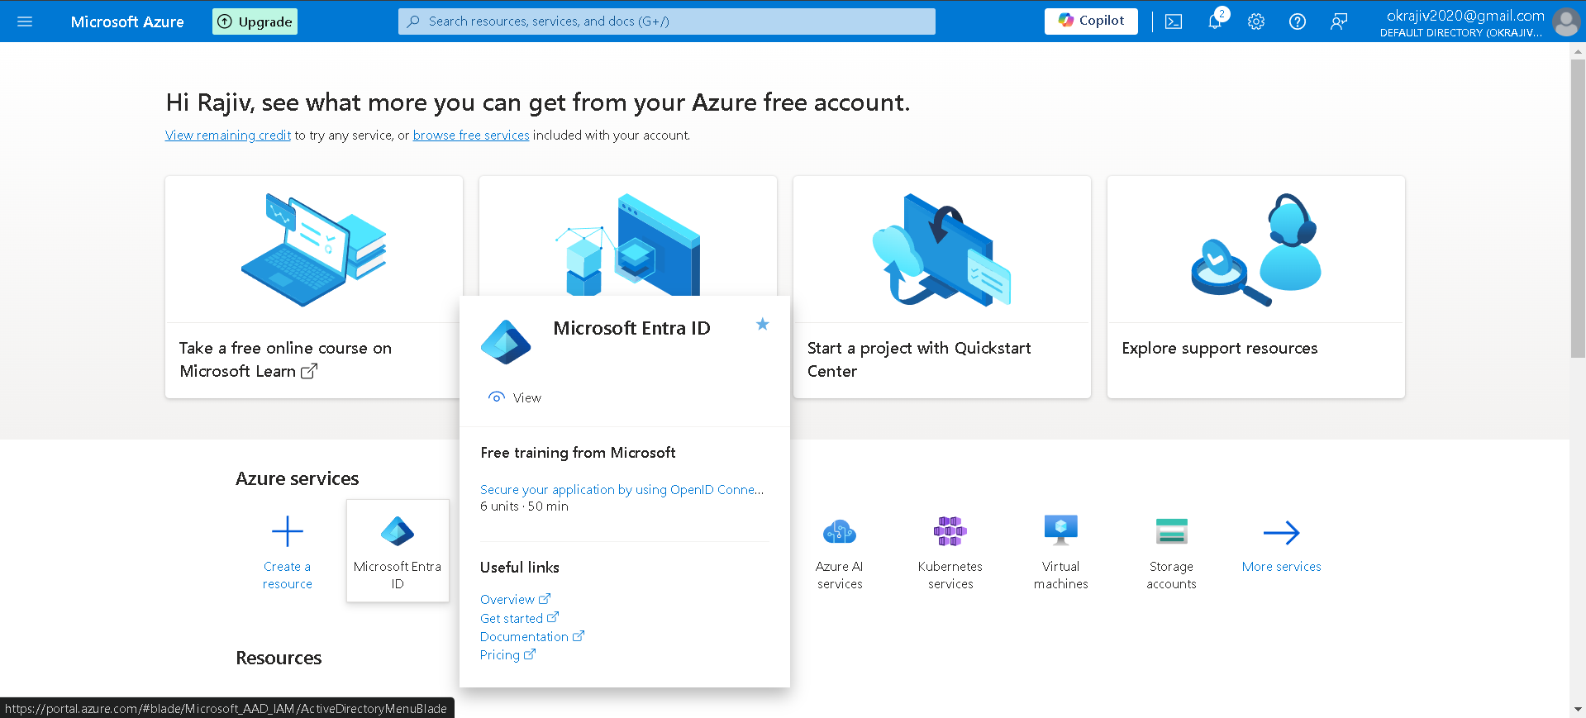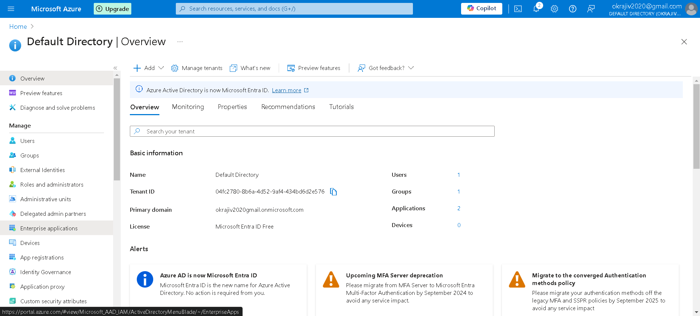

1. **Create a New Enterprise Application**
   * Select **Enterprise applications** from the sidebar.
   * Click on **New application**.

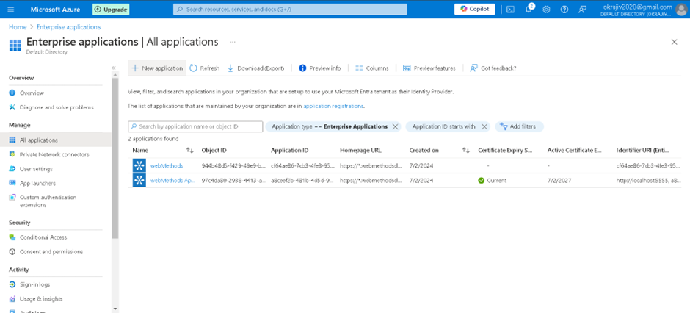

* + In the search bar, type webMethods and select the webMethods application.
  + Name your application (e.g., "webMethods SSO") and click on **Create**.

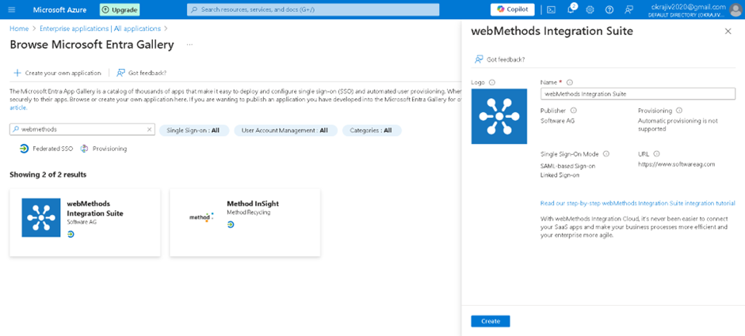

1. **Configure Single Sign-On**
   * Once the application is created, click on **Set up single sign on**.

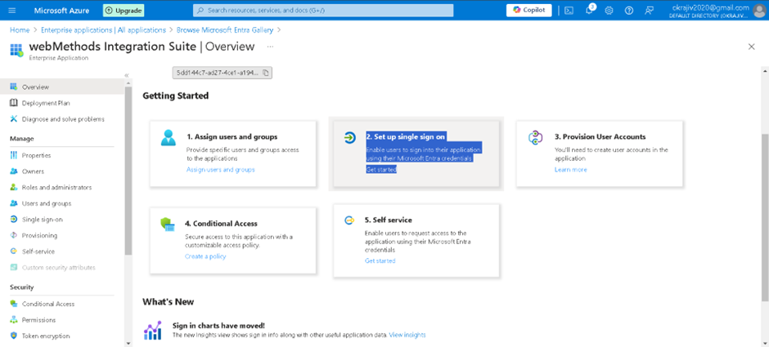

* + Select **SAML** as the single sign-on method.

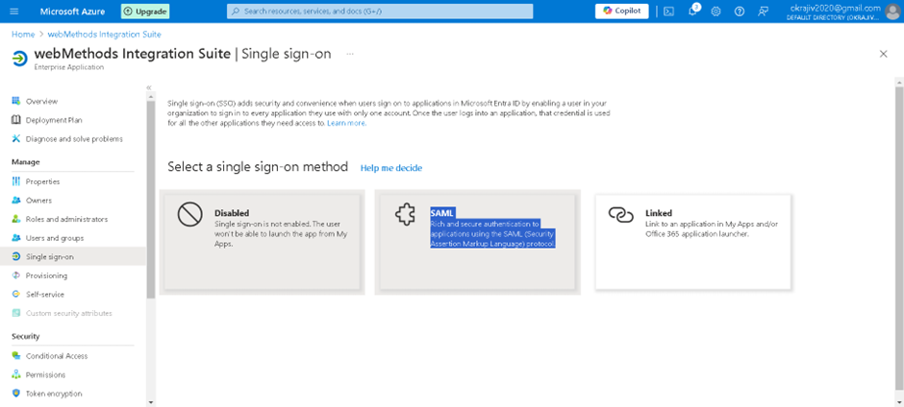

1. **Basic SAML Configuration**
   * In the Basic SAML Configuration section, click on **Edit**.

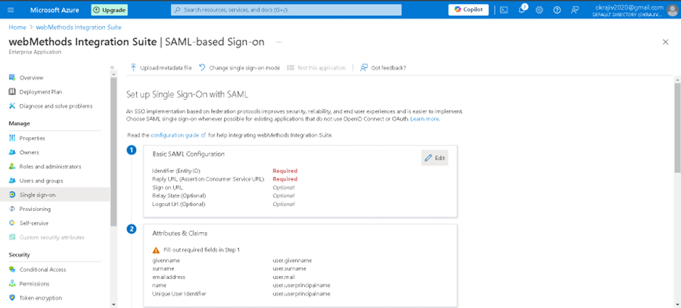

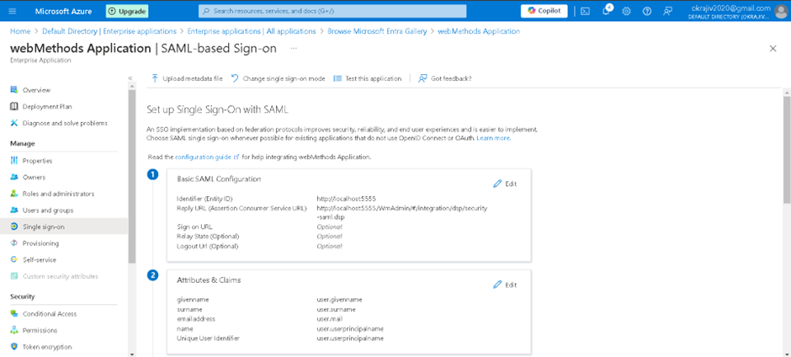

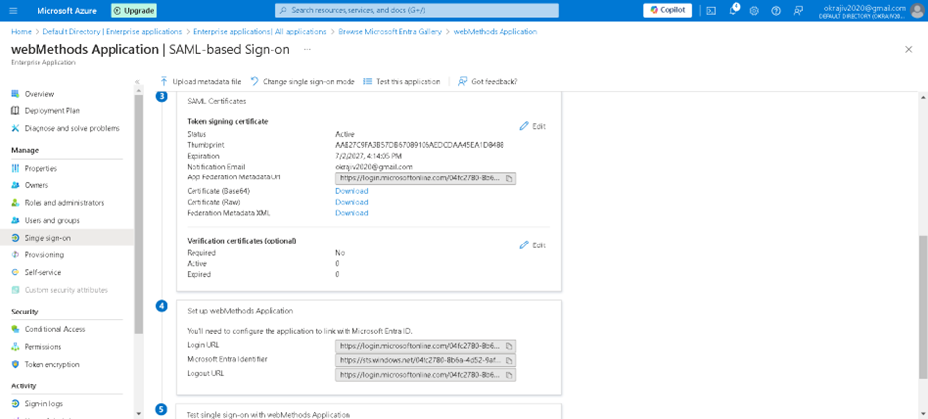

**Step 2: Obtain Entity ID and ACS URL from webMethods Integration Server**

1. **Access Integration Server Admin Console**
   * Open a web browser and go to the Integration Server Admin Console, typically available at http://<hostname>:5555.
2. **Navigate to SAML Settings**
   * Go to **Security** > **SAML**.
3. **Copy Entity ID and ACS URL**
   * **Entity ID**: This is usually the URL of your Integration Server, e.g., http://<hostname>:5555.



* + **Assertion Consumer Service (ACS) URL**: This is typically http://<hostname>:5555/invoke/wm/saml/acs.



**Step 3: Configure Basic SAML Settings in Azure AD**

1. **Input SAML Configuration in Azure AD**
   * In the Azure AD portal, input the Entity ID and ACS URL obtained from the webMethods Integration Server.
     + **Identifier (Entity ID)**: http://<hostname>:5555
     + **Reply URL (Assertion Consumer Service URL)**: http://<hostname>:5555/invoke/wm/saml/acs
   * Click on **Save**.
2. **Download Federation Metadata XML**
   * Scroll down and download the **Federation Metadata XML**. This file contains necessary information to configure the IdP settings in Okta.

**Step 4: Setting Up the Application in Okta**

1. **Login to Okta Admin Console**
   * Navigate to the Okta Admin Console.
2. **Create a New Application**
   * Select **Applications** > **Applications** from the sidebar.

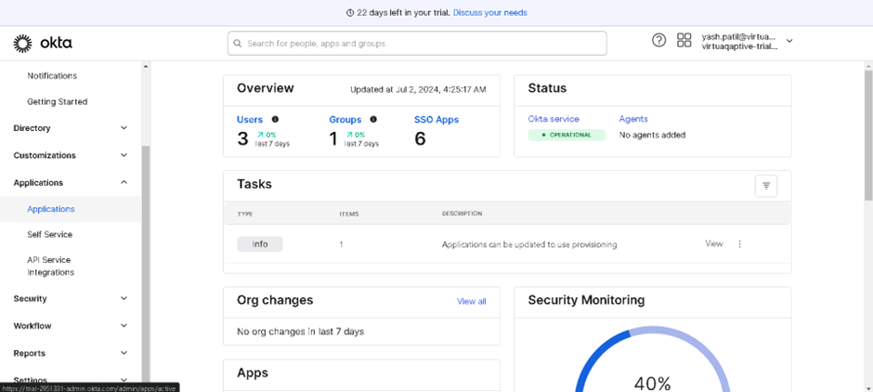

* + Click on **Create App Integration**.
  + Select **SAML 2.0** and click **Next**.

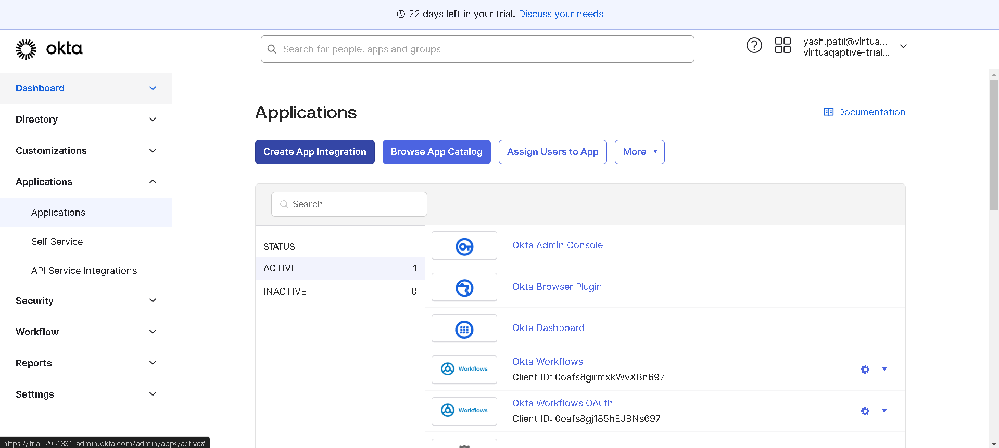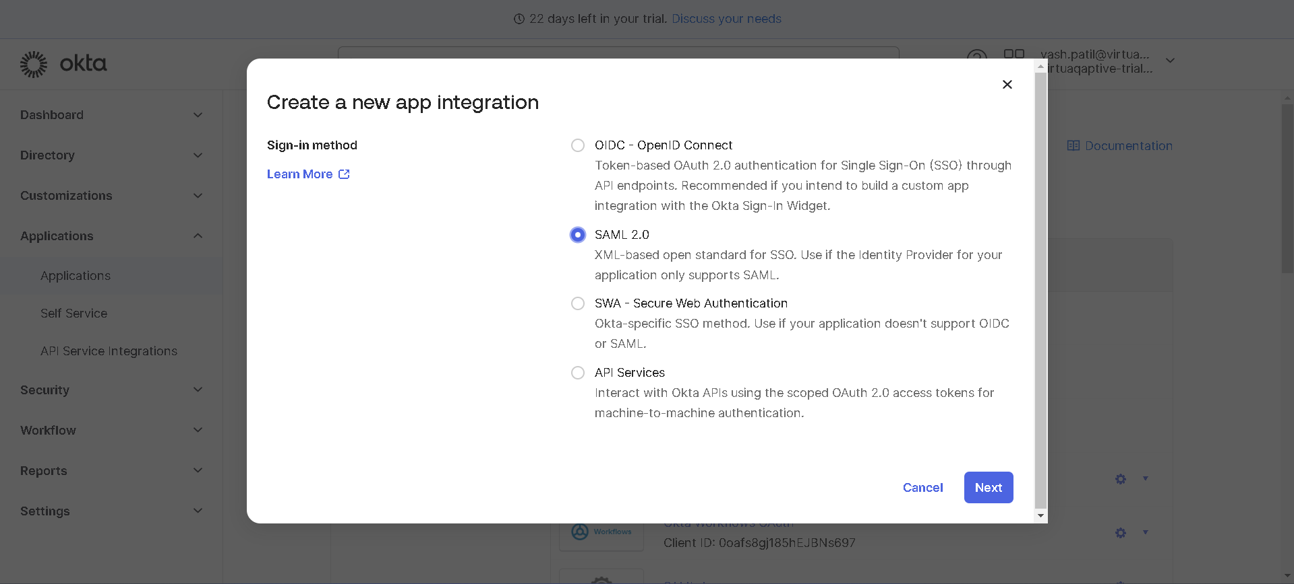

1. **Configure SAML Settings in Okta**
   * **App name**: Enter a name for your SAML application (e.g., "webMethods SAML App").
   * Optionally, upload a logo.

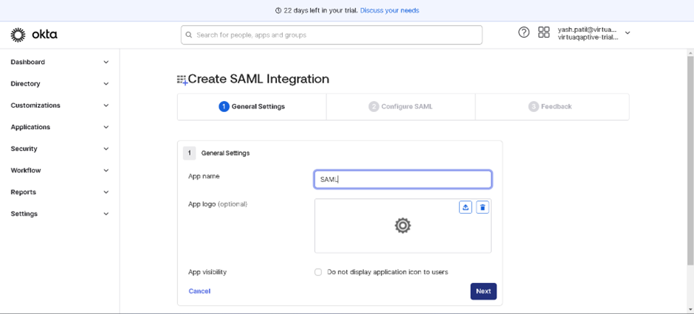

* + Click **Next**.

1. **Input SAML Details**
   * **Single sign-on URL**: Obtain this URL from Azure AD. It typically looks like https://login.microsoftonline.com/04fc2780-8b6a-4d52-9af4-434bd6d2e576/saml2.
   * **Audience URI (SP Entity ID)**: Use the Entity ID from the webMethods Integration Server (http://<hostname>:5555).
   * **Default RelayState**: This can typically be left blank unless specific requirements are stated by your application.
   * Click **Next** to create the app.

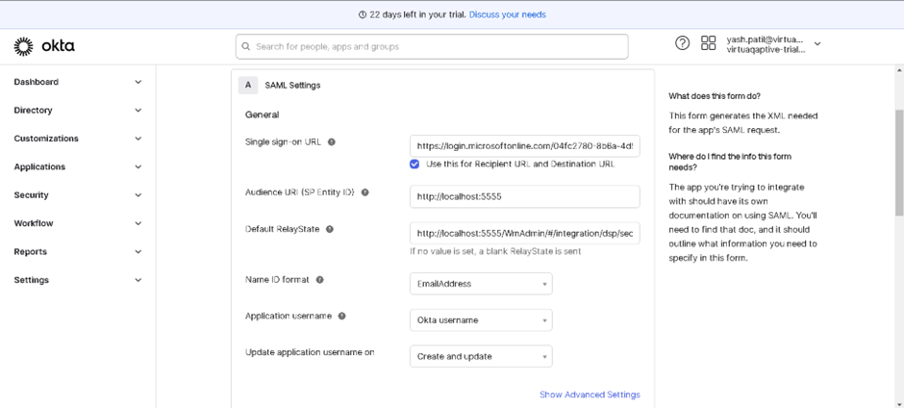

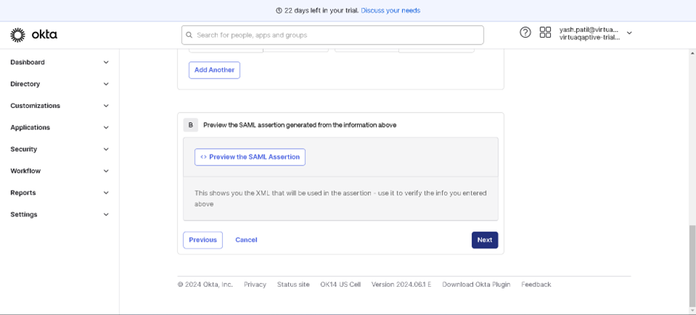

1. **Obtain Metadata URL from Okta**
   * Once the app is created, copy the **Metadata URL** provided by Okta.

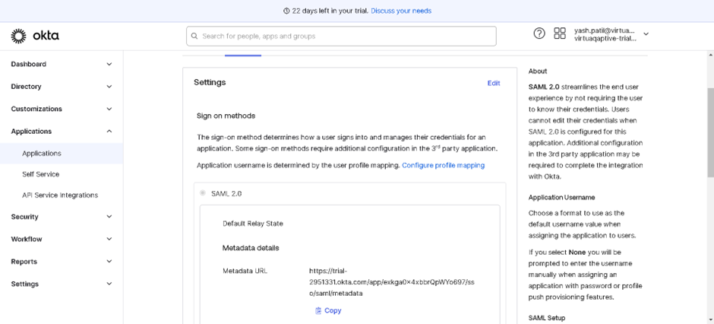

**Step 5: Configure SAML in webMethods Integration Server**

1. **Access SAML Settings in Integration Server**
   * Go back to the Integration Server Admin Console.
   * Navigate to **Security** > **SAML**.
2. **Add SAML Token**
   * Click on **Add SAML Token**.
   * **Metadata URL**: Paste the Metadata URL copied from Okta.
   * **Truststore**: Select the default truststore or an appropriate truststore that you have configured.
   * Click **Save**.

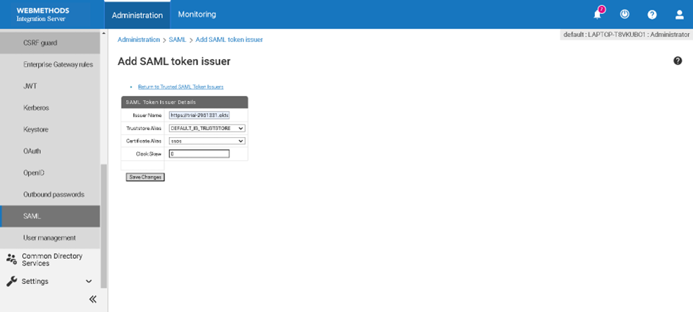

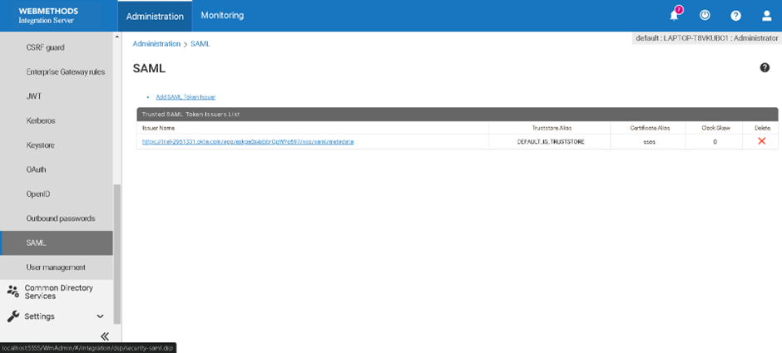

**Chapter 9: Compliance with GDPR**

**Q9. How do Software AG products provide functionality with respect to processing of personal data according to the EU General Data Protection Regulation (GDPR)?**

Software AG products are designed to help organizations comply with the EU General Data Protection Regulation (GDPR) by offering various functionalities and features. These features ensure the secure processing, storage, and management of personal data. Below are key functionalities provided by Software AG products to support GDPR compliance:

**1. Data Protection by Design and Default**

**Data Minimization**

* **Description**: Ensure that only necessary personal data is collected and processed.
* **Implementation**:
  + Configure data collection forms to limit the scope of personal data.
  + Implement data masking and anonymization techniques.

**Data Encryption**

* **Description**: Protect personal data through encryption both at rest and in transit.
* **Implementation**:
  + Enable encryption for databases and file storage systems.
  + Use secure communication protocols (e.g., HTTPS, SFTP) for data transmission.

**2. Data Subject Rights**

**Right to Access**

* **Description**: Allow individuals to access their personal data.
* **Implementation**:
  + Provide interfaces for data subjects to request and view their personal data.
  + Use APIs to facilitate data access requests.

**Right to Rectification**

* **Description**: Enable data subjects to correct inaccurate personal data.
* **Implementation**:
  + Offer self-service portals for data subjects to update their information.
  + Implement workflows to handle rectification requests.

**Right to Erasure**

* **Description**: Ensure personal data can be deleted upon request.
* **Implementation**:
  + Provide tools for data deletion and secure erasure.
  + Maintain audit trails for data deletion requests.

**3. Data Security and Breach Notification**

**Data Security Measures**

* **Description**: Implement robust security measures to protect personal data.
* **Implementation**:
  + Use access controls, firewalls, and intrusion detection systems.
  + Regularly update software and apply security patches.

**Breach Notification**

* **Description**: Notify authorities and affected individuals in case of a data breach.
* **Implementation**:
  + Implement incident response plans.
  + Use automated notification systems to alert relevant parties.

**4. Data Processing Accountability**

**Data Protection Impact Assessments (DPIAs)**

* **Description**: Conduct DPIAs for high-risk data processing activities.
* **Implementation**:
  + Provide templates and tools for conducting DPIAs.
  + Maintain records of DPIAs and their outcomes.

**Record Keeping**

* **Description**: Maintain detailed records of data processing activities.
* **Implementation**:
  + Use logging and monitoring tools to track data processing activities.
  + Store records in a secure and accessible manner.

**5. Compliance Management**

**Policy Enforcement**

* **Description**: Enforce data protection policies across the organization.
* **Implementation**:
  + Use policy management tools to define and enforce data protection policies.
  + Regularly audit compliance with policies.

**Training and Awareness**

* **Description**: Provide training and raise awareness about data protection.
* **Implementation**:
  + Offer training programs for employees on GDPR requirements.
  + Use e-learning platforms and regular updates to keep employees informed.

**Steps to Implement GDPR Compliance with Software AG Products**

1. **Evaluate Current Data Processing Activities**:
   * Assess current data processing activities and identify areas that require compliance improvements.
   * Conduct a data audit to understand what personal data is being processed.
2. **Configure Data Protection Measures**:
   * Implement data minimization, encryption, and access controls.
   * Use Software AG tools to configure and enforce these measures.
3. **Establish Data Subject Rights Processes**:
   * Set up processes for data subjects to exercise their rights (access, rectification, erasure).
   * Use self-service portals and APIs to facilitate these processes.
4. **Implement Security and Breach Notification Protocols**:
   * Enhance data security measures and establish breach notification protocols.
   * Regularly test incident response plans and update them as needed.
5. **Conduct DPIAs and Maintain Records**:
   * Perform DPIAs for high-risk processing activities.
   * Use logging tools to maintain accurate records of all data processing activities.
6. **Enforce Policies and Train Employees**:
   * Use policy management tools to enforce data protection policies.
   * Provide ongoing training and awareness programs for employees.

**Chapter 10: Using the webMethods ActiveTransfer Web Client**

**Q10. How does the webMethods ActiveTransfer Web Client User’s Guide describe the usage of the webMethods ActiveTransfer web client to view and manage files and folders in the ActiveTransfer Server instance?**

The webMethods ActiveTransfer Web Client User’s Guide provides comprehensive instructions on how to use the webMethods ActiveTransfer web client for managing files and folders within the ActiveTransfer Server instance. This includes accessing, uploading, downloading, and organizing files and folders, provided you have the necessary access privileges. Below is a detailed explanation of how to perform these tasks using the web client.

**1. Accessing the Web Client**

**Logging In**

* **Description**: Access the ActiveTransfer web client through a web browser.
* **Steps**:
  1. Open a web browser and enter the URL for the ActiveTransfer web client.
  2. Enter your username and password.
  3. Click Login to access the web client interface.

**Navigating the Interface**

* **Description**: Familiarize yourself with the web client interface, including the file manager and toolbar.
* **Key Areas**:
  + **File Manager**: Displays the files and folders you have access to.
  + **Toolbar**: Provides quick access to common actions such as upload, download, delete, and refresh.

**2. Viewing Files and Folders**

**Browsing Files and Folders**

* **Description**: Navigate through the directory structure to find and view files and folders.
* **Steps**:
  1. Use the file manager to browse directories.
  2. Click on folders to open them and view their contents.
  3. Use the breadcrumb navigation at the top to move back to previous directories.

**Searching for Files**

* **Description**: Use the search functionality to quickly locate files.
* **Steps**:
  1. Enter keywords in the search bar located at the top of the file manager.
  2. Press Enter to execute the search.
  3. View and select from the search results.

**3. Managing Files and Folders**

**Uploading Files**

* **Description**: Upload files from your local system to the ActiveTransfer Server.
* **Steps**:
  1. Click the Upload button on the toolbar.
  2. Select files from your local system.
  3. Click Open to upload the selected files.

**Downloading Files**

* **Description**: Download files from the ActiveTransfer Server to your local system.
* **Steps**:
  1. Select the files you want to download from the file manager.
  2. Click the Download button on the toolbar.
  3. Choose the location on your local system to save the files.

**Creating Folders**

* **Description**: Organize files by creating new folders.
* **Steps**:
  1. Click the New Folder button on the toolbar.
  2. Enter a name for the new folder.
  3. Click Create to add the folder to the current directory.

**Moving Files and Folders**

* **Description**: Rearrange files and folders within the directory structure.
* **Steps**:
  1. Select the files or folders you want to move.
  2. Click the Move button on the toolbar.
  3. Navigate to the destination folder.
  4. Click Move Here to complete the action.

**Deleting Files and Folders**

* **Description**: Remove unwanted files and folders.
* **Steps**:
  1. Select the files or folders you want to delete.
  2. Click the Delete button on the toolbar.
  3. Confirm the deletion when prompted.

**4. Additional Features**

**File Preview**

* **Description**: Preview the contents of files without downloading them.
* **Steps**:
  1. Select the file you want to preview.
  2. Click the Preview button (if available) on the toolbar.
  3. View the file contents in the preview window.

**Sharing Files**

* **Description**: Share files with other users by generating shareable links.
* **Steps**:
  1. Select the file you want to share.
  2. Click the Share button on the toolbar.
  3. Configure share settings and generate the shareable link.
  4. Copy the link and send it to the intended recipients.

**Viewing File Properties**

* **Description**: View detailed information about files and folders, such as size, type, and modification date.
* **Steps**:
  1. Select the file or folder.
  2. Click the Properties button on the toolbar.
  3. Review the displayed information.

**Steps for Using the Web Client**

To effectively use the webMethods ActiveTransfer web client for file and folder management, follow these steps:

1. **Log In**:
   * Access the web client via your browser.
   * Enter your credentials and log in.
2. **Browse Files and Folders**:
   * Navigate the directory structure to find necessary files.
   * Use the search bar for quick file location.
3. **Manage Files and Folders**:
   * Upload new files from your local system.
   * Download files to your local system.
   * Create new folders for better organization.
   * Move files to different directories as needed.
   * Delete unnecessary files and folders.
4. **Use Additional Features**:
   * Preview files to avoid unnecessary downloads.
   * Share files using shareable links.
   * View detailed file properties for more information.

**Chapter 11: Localization Support in ActiveTransfer**

**Q11. How does ActiveTransfer support the localization of the web client user interface?**

ActiveTransfer supports the localization of its web client user interface to cater to users from different regions and linguistic backgrounds. This localization ensures that users can interact with the web client in their preferred language, enhancing usability and accessibility. Here’s how ActiveTransfer supports localization:

**1. Language Selection**

**Description**

ActiveTransfer web client allows users to select their preferred language for the user interface.

**Steps**

1. **Access Language Settings**:
   * Log in to the ActiveTransfer web client.
   * Navigate to the user profile or settings menu.
2. **Select Preferred Language**:
   * Find the language selection option.
   * Choose the desired language from the list of available options.
3. **Apply Changes**:
   * Save the changes.
   * The interface will refresh and display in the selected language.

**2. Supported Languages**

**Description**

ActiveTransfer provides support for multiple languages to accommodate a diverse user base.

**Commonly Supported Languages**

* English
* German
* French
* Spanish
* Chinese
* Japanese
* Korean

**3. Automatic Language Detection**

**Description**

ActiveTransfer can automatically detect the user’s browser language settings and adjust the interface language accordingly.

**Steps**

1. **Browser Language Settings**:
   * Ensure the browser language settings are correctly configured.
   * Open the ActiveTransfer web client in the browser.
2. **Automatic Adjustment**:
   * The web client will detect the browser language settings.
   * The interface will automatically switch to the detected language if supported.

**4. Custom Localization Files**

**Description**

Administrators can customize localization files to add support for additional languages or modify existing translations.

**Steps**

1. **Locate Localization Files**:
   * Access the ActiveTransfer server installation directory.
   * Navigate to the localization files directory.
2. **Edit Localization Files**:
   * Open the localization file for the desired language.
   * Add or modify translation entries as needed.
3. **Deploy Changes**:
   * Save the changes to the localization file.
   * Restart the ActiveTransfer web client to apply the new translations.

**5. User Preferences**

**Description**

Users can set their language preferences within their profile settings, allowing for a personalized experience.

**Steps**

1. **Access Profile Settings**:
   * Log in to the ActiveTransfer web client.
   * Navigate to the profile settings menu.
2. **Set Language Preference**:
   * Select the preferred language from the available options.
   * Save the changes.
3. **Interface Adjustment**:
   * The web client interface will refresh and display in the selected language.

**Benefits of Localization**

**Enhanced User Experience**

* Localization allows users to interact with the web client in their native language, making it more intuitive and user-friendly.

**Increased Accessibility**

* Supporting multiple languages ensures that the web client is accessible to a wider audience, including non-English speakers.

**Improved Productivity**

* Users can navigate and operate the web client more efficiently when it is in their preferred language, leading to improved productivity.

**Steps to Implement Localization**

To effectively implement localization in the ActiveTransfer web client, follow these steps:

1. **Set Up Language Preferences**:
   * Users can select their preferred language from the settings menu.
2. **Configure Automatic Language Detection**:
   * Ensure the browser language settings are correct for automatic detection.
3. **Customize Localization Files**:
   * Administrators can edit localization files to support additional languages or modify translations.
4. **Utilize User Preferences**:
   * Encourage users to set their language preferences in their profile settings for a personalized experience.

**Chapter 12: Rebranding the ActiveTransfer Web Client Interface**

**Q12. How can you rebrand the web client interface by modifying the files located in the Integration Server directory \instances\instance_name\packages\WmMFT\resources\WebInterface\ folder?**

Rebranding the ActiveTransfer web client interface involves customizing the visual elements and layout to align with your organization's branding guidelines. This can be achieved by modifying the files located in the Integration Server_directory\instances\instance_name\packages\WmMFT\resources\WebInterface\ folder. Below is a detailed guide on how to perform these customizations.

**1. Accessing the WebInterface Folder**

**Description**

The WebInterface folder contains all the necessary resources for the web client's interface, including HTML, CSS, JavaScript, and image files.

**Steps**

1. **Navigate to the Directory**:
   * Open the file explorer on your server.
   * Navigate to the path: Integration Server_directory\instances\instance_name\packages\WmMFT\resources\WebInterface\.
2. **Identify Key Files**:
   * Locate the HTML, CSS, JavaScript, and image files that you will modify for rebranding.

**2. Customizing HTML Files**

**Description**

HTML files define the structure of the web client interface. Modifying these files allows you to change the layout and content.

**Steps**

1. **Open HTML Files**:
   * Use a text editor or an HTML editor to open the HTML files located in the WebInterface folder.
2. **Modify Content**:
   * Update the content, such as text and links, to reflect your organization's branding.
   * Ensure that any new elements added align with the overall design and functionality.
3. **Save Changes**:
   * Save the modified HTML files and verify that they are correctly updated.

**3. Customizing CSS Files**

**Description**

CSS files control the styling of the web client interface, including colors, fonts, and layout. Modifying these files allows you to change the appearance to match your brand.

**Steps**

1. **Open CSS Files**:
   * Use a text editor or a CSS editor to open the CSS files located in the WebInterface folder.
2. **Update Styles**:
   * Modify styles to incorporate your brand's color scheme, fonts, and other design elements.
   * Ensure consistency in the styling across all elements of the web client.
3. **Save Changes**:
   * Save the modified CSS files and verify that the styles are correctly applied.

**4. Customizing JavaScript Files**

**Description**

JavaScript files control the dynamic behavior of the web client interface. Modifying these files allows you to add or alter interactive elements.

**Steps**

1. **Open JavaScript Files**:
   * Use a text editor or a JavaScript editor to open the JavaScript files located in the WebInterface folder.
2. **Modify Scripts**:
   * Update scripts to add new functionality or modify existing behavior.
   * Ensure that any changes made do not disrupt the core functionality of the web client.
3. **Save Changes**:
   * Save the modified JavaScript files and verify that the changes are correctly implemented.

**5. Customizing Image Files**

**Description**

Image files include logos, icons, and other visual elements. Replacing these files with your branded images allows you to visually rebrand the web client.

**Steps**

1. **Prepare Branded Images**:
   * Create or obtain images that reflect your organization's branding, such as logos and icons.
   * Ensure that the images are of appropriate size and resolution.
2. **Replace Image Files**:
   * Locate the image files in the WebInterface folder that you wish to replace.
   * Rename your branded images to match the existing file names.
   * Replace the existing files with your branded images.
3. **Verify Changes**:
   * Check the web client to ensure that the new images are correctly displayed.

**6. Testing the Rebranded Interface**

**Description**

After making the modifications, it is crucial to test the web client to ensure that all changes are correctly applied and that the interface functions as expected.

**Steps**

1. **Clear Browser Cache**:
   * Clear the browser cache to ensure that the latest versions of the files are loaded.
2. **Access the Web Client**:
   * Log in to the ActiveTransfer web client using a web browser.
3. **Verify Modifications**:
   * Check that all visual and functional changes are correctly implemented.
   * Test various features to ensure that the core functionality is not disrupted.
4. **Gather Feedback**:
   * If possible, gather feedback from other users to identify any issues or further improvements needed.

**Benefits of Rebranding**

**Enhanced User Experience**

* A customized interface provides a familiar and cohesive experience for users, enhancing usability.

**Consistent Branding**

* Rebranding ensures that the web client aligns with your organization's overall branding, promoting brand recognition and consistency.

**Increased Engagement**

* A visually appealing and branded interface can increase user engagement and satisfaction.

**Steps to Rebrand the Web Client Interface**

To rebrand the ActiveTransfer web client interface, follow these steps:

1. **Access the WebInterface Folder**:
   * Navigate to Integration Server_directory\instances\instance_name\packages\WmMFT\resources\WebInterface\.
2. **Customize HTML Files**:
   * Modify the content and structure in the HTML files.
3. **Customize CSS Files**:
   * Update styles to reflect your brand's color scheme, fonts, and design elements.
4. **Customize JavaScript Files**:
   * Add or alter interactive elements in the JavaScript files.
5. **Customize Image Files**:
   * Replace existing images with your branded visuals.
6. **Test the Rebranded Interface**:
   * Clear browser cache, verify all changes, and ensure core functionality remains intact.

**Chapter 13: Managing Files with ActiveTransfer Web Client**

**Q13. How to Add Files and Folders to the Basket using ActiveTransfer Web Client**

ActiveTransfer web client includes a feature known as the "Basket" which allows users to manage multiple files and folders efficiently. The Basket feature is designed to help users collect and organize files and folders before performing bulk operations such as downloading, moving, or deleting. Here is a detailed guide on how to add files and folders to the Basket using the ActiveTransfer web client:

**1. Accessing the Web Client**

**Description**

Before you can add files and folders to the Basket, you need to log in to the ActiveTransfer web client.

**Steps**

1. **Log In**:
   * Open your web browser and navigate to the ActiveTransfer web client URL.
   * Enter your username and password.
   * Click Login to access the web client interface.
2. **Navigate to File Manager**:
   * Once logged in, navigate to the File Manager section where you can view your files and folders.

**2. Selecting Files and Folders**

**Description**

Identify and select the files and folders you want to add to the Basket.

**Steps**

1. **Browse Files and Folders**:
   * Use the file manager to navigate through the directory structure to locate the desired files and folders.
2. **Select Items**:
   * Click on the checkboxes next to the files and folders you want to add to the Basket. You can select multiple items at once.

**3. Adding to the Basket**

**Description**

Use the Basket feature to collect the selected files and folders.

**Steps**

1. **Add to Basket**:
   * After selecting the files and folders, look for the Add to Basket button typically located in the toolbar or context menu.
   * Click Add to Basket. The selected items will be added to your Basket.
2. **View Basket Contents**:
   * To view the contents of your Basket, navigate to the Basket icon or section in the web client interface.
   * Click on the Basket to see all the items you have added.

**4. Managing Basket Contents**

**Description**

Once files and folders are in the Basket, you can manage them as a group.

**Steps**

1. **Review Basket**:
   * Open the Basket to review the collected files and folders.
2. **Perform Operations**:
   * You can now perform bulk operations on the items in the Basket, such as:
     + **Download**: Click the Download button to download all items in the Basket at once.
     + **Move**: Click the Move button to relocate the items to a different directory.
     + **Delete**: Click the Delete button to remove all items in the Basket.
     + **Copy**: Click the Copy button to duplicate the items in another location.
3. **Remove Items from Basket**:
   * If you want to remove certain items from the Basket, select the items within the Basket view and click Remove from Basket.

**5. Clearing the Basket**

**Description**

Clear the Basket when you are done managing the collected items.

**Steps**

1. **Clear Basket**:
   * To clear all items from the Basket, click the Clear Basket button.
   * Confirm the action if prompted. This will remove all items from the Basket.

**Benefits of Using the Basket Feature**

**Efficient File Management**

* The Basket allows for efficient bulk management of files and folders, saving time and effort.

**Organized Operations**

* By collecting items in the Basket, you can organize and review them before performing operations, reducing the risk of errors.

**Streamlined Workflow**

* The Basket feature streamlines workflows by enabling bulk actions, making file management more straightforward and efficient.

**Steps to Add Files and Folders to the Basket**

To effectively add files and folders to the Basket using the ActiveTransfer web client, follow these steps:

1. **Log In**:
   * Access the ActiveTransfer web client and log in with your credentials.
2. **Select Items**:
   * Browse and select the files and folders you wish to add to the Basket.
3. **Add to Basket**:
   * Click the Add to Basket button to collect the selected items.
4. **Manage Basket Contents**:
   * Review the Basket and perform bulk operations such as downloading, moving, copying, or deleting.
5. **Clear the Basket**:
   * Clear the Basket when finished managing the items.

**Chapter 14: Managing Files with ActiveTransfer Web Client**

**Q14. How to View and Copy Files and Folders to the Basket using ActiveTransfer Web Client**

ActiveTransfer web client includes a feature known as the "Basket" which allows users to manage multiple files and folders efficiently. The Basket feature helps users collect, organize, and perform bulk operations on files and folders. Here is a detailed guide on how to view and copy files and folders to the Basket using the ActiveTransfer web client:

**1. Accessing the Web Client**

**Description**

Before you can view and copy files and folders to the Basket, you need to log in to the ActiveTransfer web client.

**Steps**

1. **Log In**:
   * Open your web browser and navigate to the ActiveTransfer web client URL.
   * Enter your username and password.
   * Click Login to access the web client interface.
2. **Navigate to File Manager**:
   * Once logged in, navigate to the File Manager section where you can view your files and folders.

**2. Viewing Files and Folders**

**Description**

Browse and view the files and folders in your ActiveTransfer Server instance.

**Steps**

1. **Browse Files and Folders**:
   * Use the file manager to navigate through the directory structure and view your files and folders.
2. **Select Items**:
   * Click on the checkboxes next to the files and folders you want to view or copy to the Basket. You can select multiple items at once.

**3. Copying Files and Folders to the Basket**

**Description**

Copy the selected files and folders to the Basket for further operations.

**Steps**

1. **Add to Basket**:
   * After selecting the files and folders, look for the Add to Basket button typically located in the toolbar or context menu.
   * Click Add to Basket. The selected items will be copied to your Basket.
2. **View Basket Contents**:
   * To view the contents of your Basket, navigate to the Basket icon or section in the web client interface.
   * Click on the Basket to see all the items you have added.

**4. Managing Basket Contents**

**Description**

Once files and folders are in the Basket, you can manage them as a group.

**Steps**

1. **Review Basket**:
   * Open the Basket to review the collected files and folders.
2. **Perform Operations**:
   * You can now perform bulk operations on the items in the Basket, such as:
     + **Download**: Click the Download button to download all items in the Basket at once.
     + **Move**: Click the Move button to relocate the items to a different directory.
     + **Delete**: Click the Delete button to remove all items in the Basket.
     + **Copy**: Click the Copy button to duplicate the items in another location.
3. **Remove Items from Basket**:
   * If you want to remove certain items from the Basket, select the items within the Basket view and click Remove from Basket.

**5. Clearing the Basket**

**Description**

Clear the Basket when you are done managing the collected items.

**Steps**

1. **Clear Basket**:
   * To clear all items from the Basket, click the Clear Basket button.
   * Confirm the action if prompted. This will remove all items from the Basket.

**Benefits of Using the Basket Feature**

**Efficient File Management**

* The Basket allows for efficient bulk management of files and folders, saving time and effort.

**Organized Operations**

* By collecting items in the Basket, you can organize and review them before performing operations, reducing the risk of errors.

**Streamlined Workflow**

* The Basket feature streamlines workflows by enabling bulk actions, making file management more straightforward and efficient.

**Steps to View and Copy Files and Folders to the Basket**

To effectively view and copy files and folders to the Basket using the ActiveTransfer web client, follow these steps:

1. **Log In**:
   * Access the ActiveTransfer web client and log in with your credentials.
2. **Select Items**:
   * Browse and select the files and folders you wish to view and copy to the Basket.
3. **Add to Basket**:
   * Click the Add to Basket button to copy the selected items to the Basket.
4. **Manage Basket Contents**:
   * Review the Basket and perform bulk operations such as downloading, moving, copying, or deleting.
5. **Clear the Basket**:
   * Clear the Basket when finished managing the items.

**Chapter 15: File Sharing in ActiveTransfer**

**Question 15: How is Sharing Possible from Both ActiveTransfer Server and ActiveTransfer Gateway?**

Sharing files and folders is a crucial feature in webMethods ActiveTransfer, allowing users to collaborate efficiently and securely. Both ActiveTransfer Server and ActiveTransfer Gateway facilitate file sharing, albeit with different focuses and mechanisms. This chapter provides a detailed explanation of how sharing is possible from both the ActiveTransfer Server and ActiveTransfer Gateway.

**Sharing from ActiveTransfer Server**

**Description:** ActiveTransfer Server offers comprehensive file sharing capabilities directly from the server to internal and external users. It supports various protocols and ensures secure file transfers.

**Steps:**

1. **Log In to ActiveTransfer Server:**
   * Open your web browser and navigate to the ActiveTransfer Server URL.
   * Enter your username and password to log in.
2. **Navigate to File Manager:**
   * Once logged in, go to the **File Manager** section to view the files and folders you wish to share.
3. **Select Files and Folders:**
   * Use the file manager to browse and select the files and folders you want to share.
   * Click on the checkboxes next to the items to select them.
4. **Generate Sharing Link:**
   * After selecting the items, click on the **Share** button typically found in the toolbar or context menu.
   * A sharing link will be generated. You can set permissions such as read-only or read-write and configure the expiration date for the link.
5. **Distribute the Link:**
   * Copy the sharing link and send it to the intended recipients via email or any other communication method.

**Sharing from ActiveTransfer Gateway**

**Description:** ActiveTransfer Gateway acts as a secure intermediary for external file transfers, providing an additional layer of security and control. It is particularly useful for sharing files with external partners and clients.

**Steps:**

1. **Log In to ActiveTransfer Gateway:**
   * Open your web browser and navigate to the ActiveTransfer Gateway URL.
   * Enter your credentials to log in.
2. **Access Gateway File Manager:**
   * Once logged in, navigate to the **Gateway File Manager** section.
3. **Select Files and Folders:**
   * Browse and select the files and folders you want to share using the Gateway's file manager.
   * Click on the checkboxes next to the items to select them.
4. **Configure Sharing Settings:**
   * Click on the **Share** button. Configure sharing settings such as access permissions, password protection, and expiration dates.
   * Set additional security options like IP whitelisting to restrict access to specific IP addresses.
5. **Generate and Distribute the Link:**
   * Generate the sharing link. Copy the link and distribute it to the external recipients.
   * The recipients can access the shared files through the Gateway, ensuring secure and controlled access.

**Detailed Steps for Sharing Files and Folders**

When sharing files or folders, you create an email message to send to the recipients of the file share. The email contains a link to the shared item, the expiration date, and the user credentials to access the shared item.

**To Share a File or Folder:**

1. **Select the Item:**
   * In the web client, select the checkbox for the file or folder that you want to share.
   * Click **Share** on the toolbar at the top of the page.
   * The **Share** dialog box appears, displaying the selected files or folders for sharing.
2. **Direct Link Option:**
   * If sharing a single file and you want the user to view it directly upon clicking the link in the email, select **Direct link to file.**
3. **Select Share Type:**
   * In the **Share Type** field, choose how to share the selected items:
     + **Copy:** Makes a copy of the original shared item and stores it in a temporary location. The link remains functional even if the original item is deleted. The item is deleted from temporary storage when the link expires.
     + **Reference:** Creates a pointer to the original shared item. Any changes made by the recipient will affect the original file. Renaming the original item will break the link.
     + **Move:** Moves the original shared file to a temporary storage location. The original file is deleted from temporary storage when the link expires.
4. **Send Email Notification:**
   * To send an email, keep the default selection of **Send Email**. All recipients will receive a message regarding the shared item.
   * To skip sending an email, clear the **Send Email** selection.
5. **Set Expiration:**
   * In the **Expires** field, specify the number of days the item will be accessible.
   * Set the exact expiration time (24-hour format hh).
6. **Complete Email Fields:**
   * If sending an email, complete the **From**, **To**, **CC**, **BCC**, **Subject**, and **Body** fields as required.
   * In the **To**, **CC**, and **BCC** fields, include multiple email IDs separated by commas.
7. **Set Permissions:**
   * Select the relevant access permissions for the shared item: **View**, **Download**, **Upload**, **Delete**, **Rename**, **Create Folder**, **Delete Folder**.
   * **View** permission is selected by default. Retain this selection to enable other access permissions.
8. **Send Email:**
   * Click **Send** to send an email about the shared items.

**Benefits of Using Both ActiveTransfer Server and Gateway for Sharing**

* **Enhanced Security:**
  + The Gateway adds an extra layer of security for external sharing, protecting the internal network and sensitive data.
* **Flexibility:**
  + Users can choose to share files directly from the server for internal use or through the Gateway for external sharing, providing flexibility based on the use case.
* **Controlled Access:**
  + Both the Server and Gateway offer configurable access controls, ensuring that shared files are accessed only by authorized users.

**Use Case Scenarios**

* **Internal Collaboration:**
  + Use the ActiveTransfer Server to share files and folders within your organization, facilitating collaboration among team members.
* **External Sharing with Partners:**
  + Use the ActiveTransfer Gateway to securely share files with external partners, clients, and vendors, ensuring that sensitive data remains protected.

**Steps for Effective File Sharing**

To share files and folders effectively using both ActiveTransfer Server and Gateway, follow these steps:

1. **Identify Sharing Needs:**
   * Determine whether the sharing is for internal or external purposes.
2. **Log In to the Appropriate Platform:**
   * Access the ActiveTransfer Server for internal sharing or the Gateway for external sharing.
3. **Select Files and Folders:**
   * Use the file manager to select the items to be shared.
4. **Configure Sharing Settings:**
   * Set permissions, expiration dates, and other security options.
5. **Generate and Distribute Sharing Links:**
   * Generate the sharing link and distribute it to the intended recipients.

**Chapter 16: Managing File Transfers with ActiveTransfer Gateway**

**Q16. How Managing File Transfers with webMethods ActiveTransfer Gateway Explains Configuring and Managing the Gateway**

webMethods ActiveTransfer Gateway is a crucial component for managing secure file transfers, especially when dealing with external entities. It acts as a DMZ-based secure transfer point, working in tandem with the ActiveTransfer Server. This section provides a detailed explanation of how to configure the ActiveTransfer Gateway to work with the ActiveTransfer Server and manage common administrative tasks.

**1. Overview of ActiveTransfer Gateway**

**Description**

ActiveTransfer Gateway is designed to provide secure, controlled access to file transfers between external partners and the internal network. It offers additional layers of security, ensuring that sensitive data is protected during transfers.

**2. Configuring ActiveTransfer Gateway**

**Steps to Configure**

1. **Install ActiveTransfer Gateway**:
   * Download and install the ActiveTransfer Gateway software on a server located in the DMZ.
2. **Initial Setup**:
   * During the installation, provide the necessary configuration details such as server name, port numbers, and initial admin credentials.
3. **Connect to ActiveTransfer Server**:
   * Log in to the ActiveTransfer Gateway administration console.
   * Navigate to the configuration settings to establish a connection with the ActiveTransfer Server.
   * Provide the ActiveTransfer Server details such as hostname, port, and authentication credentials.
4. **Configure Gateway Settings**:
   * Set up additional security measures like IP whitelisting, SSL/TLS configurations, and user access controls.
   * Define the file transfer protocols that the Gateway will support (e.g., FTP, SFTP, HTTP).
5. **Test the Configuration**:
   * Perform a test file transfer to ensure that the Gateway is correctly configured and can communicate with the ActiveTransfer Server.

**3. Managing ActiveTransfer Gateway Instances**

**Steps to Manage**

1. **Monitor Gateway Instances**:
   * Use the administration console to monitor the health and performance of each Gateway instance.
   * Check logs regularly for any anomalies or security breaches.
2. **Update Configuration**:
   * Periodically review and update the Gateway configuration to adapt to changing security requirements and operational needs.
   * Ensure that software updates and patches are applied promptly to maintain security integrity.
3. **User Management**:
   * Manage user accounts and permissions through the Gateway administration console.
   * Regularly review user access to ensure compliance with security policies.
4. **Backup and Recovery**:
   * Set up regular backups of the Gateway configuration and related data.
   * Test the recovery process to ensure that you can restore the system in case of failure.

**Common Administrative Tasks**

**Description**

Several routine administrative tasks are necessary to maintain the smooth operation of the ActiveTransfer Gateway.

**Tasks**

1. **Log Management**:
   * Regularly review and archive logs to track user activities and detect any suspicious behavior.
2. **Security Audits**:
   * Conduct regular security audits to ensure that the Gateway complies with internal and external security standards.
3. **Performance Tuning**:
   * Monitor the performance metrics and optimize the configuration to handle peak loads efficiently.
   * Adjust resource allocations based on usage patterns to ensure optimal performance.
4. **Incident Response**:
   * Develop and maintain an incident response plan to handle security breaches or operational failures.
   * Train staff on the response procedures and conduct drills to ensure readiness.

**Benefits of Using ActiveTransfer Gateway**

**Enhanced Security**

* Provides an additional layer of security by segregating the internal network from external entities during file transfers.

**Compliance**

* Helps in meeting regulatory and compliance requirements by offering detailed logging and auditing capabilities.

**Scalability**

* Can be scaled to handle increasing file transfer loads by adding more instances or resources as needed.

**Chapter 17: Configuring a Dedicated ActiveTransfer Gateway for External Client Requests**

**Q17. How Can You Configure a Dedicated ActiveTransfer Gateway That Permits the Internal ActiveTransfer Server to Process Requests from External Clients?**

webMethods ActiveTransfer Gateway provides a secure interface for external clients to interact with the internal ActiveTransfer Server, ensuring data protection and controlled access. Configuring a dedicated ActiveTransfer Gateway involves several steps to ensure that external requests are handled securely and efficiently. This chapter provides a comprehensive guide on how to configure a dedicated ActiveTransfer Gateway.

**1. Understanding ActiveTransfer Gateway**

**Description**

ActiveTransfer Gateway acts as a secure bridge between external clients and the internal ActiveTransfer Server. It is typically deployed in a DMZ (Demilitarized Zone) to provide an added layer of security, preventing direct access to the internal network.

**2. Installation and Initial Setup**

**Steps to Install**

1. **Download the Software**:
   * Obtain the ActiveTransfer Gateway installation package from Software AG’s support portal.
2. **Install ActiveTransfer Gateway**:
   * Run the installation package on a server located in the DMZ.
   * Follow the installation wizard to complete the setup.
3. **Configure Initial Settings**:
   * During installation, you will be prompted to configure initial settings such as server name, ports, and admin credentials.
   * Ensure that these settings comply with your organization’s security policies.

**3. Connecting to ActiveTransfer Server**

**Steps to Connect**

1. **Access Administration Console**:
   * Log in to the ActiveTransfer Gateway administration console using the admin credentials set during installation.
2. **Navigate to Configuration Settings**:
   * Go to the configuration section to establish a connection with the internal ActiveTransfer Server.
3. **Provide Server Details**:
   * Enter the hostname or IP address of the internal ActiveTransfer Server.
   * Specify the port number used by the ActiveTransfer Server.
   * Provide authentication credentials to allow secure communication between the Gateway and the Server.
4. **Test Connection**:
   * Test the connection to ensure that the Gateway can communicate with the ActiveTransfer Server without issues.

**4. Configuring Gateway Settings**

**Security and Protocol Configuration**

1. **Enable SSL/TLS**:
   * Configure SSL/TLS to encrypt the communication between external clients and the Gateway.
   * Obtain and install the necessary SSL certificates.
2. **Configure Supported Protocols**:
   * Define the file transfer protocols (e.g., FTP, SFTP, HTTP/S) that the Gateway will support.
   * Ensure that these protocols align with your organization’s security policies and client requirements.
3. **Set IP Whitelisting**:
   * Configure IP whitelisting to allow only trusted external clients to access the Gateway.
   * Add the IP addresses of external clients who need access to the system.
4. **Define Access Permissions**:
   * Set up user roles and permissions to control what external clients can access and perform.
   * Ensure that permissions are restrictive enough to prevent unauthorized access.

**5. Managing and Monitoring the Gateway**

**Ongoing Administration Tasks**

1. **Regular Monitoring**:
   * Use the administration console to monitor the health and performance of the Gateway.
   * Check logs regularly for any suspicious activities or errors.
2. **Update Configuration**:
   * Periodically review and update the Gateway configuration to address changing security requirements and operational needs.
3. **User Management**:
   * Add, update, or remove user accounts and permissions as required.
   * Ensure that user access is regularly reviewed and updated based on current requirements.
4. **Backup and Recovery**:
   * Set up regular backups of the Gateway configuration and related data.
   * Test the recovery process periodically to ensure data integrity and availability.

**6. Testing and Validation**

**Ensuring Proper Functionality**

1. **Perform Test Transfers**:
   * Conduct test file transfers to verify that the Gateway correctly processes requests from external clients and communicates with the internal ActiveTransfer Server.
2. **Validate Security Settings**:
   * Check that SSL/TLS encryption, IP whitelisting, and access permissions are correctly configured and enforced.
3. **Review Logs**:
   * Examine logs for any anomalies or issues during the test transfers.

**Benefits of a Dedicated ActiveTransfer Gateway**

**Enhanced Security**

* Isolates external traffic from the internal network, reducing the risk of security breaches.

**Controlled Access**

* Provides granular control over who can access the Gateway and what actions they can perform.

**Scalability**

* Can be scaled to handle increasing volumes of external client requests by adding more Gateway instances as needed.

**Chapter 18: How ActiveTransfer Gateway Works**

**Q18. How Does ActiveTransfer Gateway Work?**

webMethods ActiveTransfer Gateway plays a crucial role in managing and securing file transfers between external clients and the internal ActiveTransfer Server. This chapter provides a detailed explanation of how ActiveTransfer Gateway works, highlighting its architecture, components, and the flow of data through the system.

**1. Overview of ActiveTransfer Gateway**

**Description**

ActiveTransfer Gateway acts as a secure intermediary that facilitates and manages file transfers between external clients and the internal network. It is typically deployed in a DMZ (Demilitarized Zone) to enhance security and control.

**2. Architecture and Components**

**Key Components**

1. **ActiveTransfer Gateway**:
   * Deployed in the DMZ, it handles incoming file transfer requests from external clients.
   * Ensures secure communication with external clients via SSL/TLS encryption.
2. **ActiveTransfer Server**:
   * Located in the internal network, it processes the file transfer requests received from the Gateway.
   * Manages user authentication, file storage, and transfer protocols.
3. **DMZ (Demilitarized Zone)**:
   * A physical or logical subnetwork that adds an extra layer of security between the internal network and the external internet.
   * Hosts the ActiveTransfer Gateway to isolate external traffic from the internal network.

**3. Data Flow and Communication**

**Steps in the Data Flow**

1. **Client Request**:
   * An external client initiates a file transfer request to the ActiveTransfer Gateway.
   * The request is encrypted using SSL/TLS to ensure secure transmission.
2. **Gateway Processing**:
   * The ActiveTransfer Gateway receives the request and performs initial validation and security checks.
   * It ensures that the request complies with defined security policies, such as IP whitelisting and user authentication.
3. **Forwarding to Server**:
   * The Gateway securely forwards the validated request to the internal ActiveTransfer Server.
   * Communication between the Gateway and the Server is also encrypted to maintain data security.
4. **Server Handling**:
   * The ActiveTransfer Server processes the request, performing necessary actions such as file upload, download, or transfer.
   * It interacts with the file storage system to retrieve or store the required files.
5. **Response Transmission**:
   * The Server sends a response back to the Gateway, confirming the success or failure of the request.
   * The Gateway then transmits this response back to the external client, completing the transaction.

**4. Security Features**

**Key Security Mechanisms**

1. **SSL/TLS Encryption**:
   * Ensures that all data transmitted between the external clients, Gateway, and Server is encrypted.
   * Protects data from interception and tampering during transmission.
2. **IP Whitelisting**:
   * Restricts access to the Gateway to only authorized IP addresses.
   * Prevents unauthorized external entities from attempting to connect to the Gateway.
3. **User Authentication and Access Control**:
   * Validates the identity of external clients and enforces access controls.
   * Ensures that only authenticated and authorized users can initiate file transfers.
4. **Audit Logs and Monitoring**:
   * Keeps detailed logs of all file transfer activities, including user actions and system events.
   * Facilitates monitoring and auditing to detect and respond to potential security incidents.

**5. Use Case Scenarios**

**Common Scenarios**

1. **External Partner Collaboration**:
   * External partners can securely upload and download files via the ActiveTransfer Gateway.
   * The Gateway ensures that external access does not compromise internal network security.
2. **Remote Employee Access**:
   * Remote employees can securely transfer files to and from the internal network through the Gateway.
   * Provides a secure method for remote work without exposing the internal network to direct access.
3. **Customer File Submissions**:
   * Customers can submit files securely to the internal systems using the Gateway.
   * Ensures that sensitive customer data is protected during transmission.

**6. Benefits of Using ActiveTransfer Gateway**

**Enhanced Security**

* Provides an additional layer of security by isolating external file transfer traffic from the internal network.

**Controlled Access**

* Offers fine-grained control over who can access the file transfer system and what actions they can perform.

**Improved Compliance**

* Helps organizations comply with regulatory requirements by providing secure and auditable file transfer mechanisms.

**Chapter 19: Prerequisites for Configuring ActiveTransfer Gateway**

**Q19. What Are the Prerequisites Before Configuring ActiveTransfer Gateway?**

Before diving into the configuration of ActiveTransfer Gateway, it is essential to ensure that several prerequisites are met. These preparatory steps are crucial for a smooth and successful configuration process, ensuring that the system is set up correctly and ready to handle file transfers securely and efficiently. This section outlines the key prerequisites that need to be addressed before starting the configuration tasks.

**1. Installation of ActiveTransfer Gateway**

**Ensure Installation**

* **ActiveTransfer Gateway Installation**:
  + Confirm that the ActiveTransfer Gateway software is installed on the server designated for it. For detailed installation instructions, refer to the section "Installing Software AG Products On Premises."

**2. Version Consistency Across Nodes**

**Uniform Versioning**

* **Gateway Node Versions**:
  + Verify that all Gateway nodes within the ActiveTransfer installation are running the same version of webMethods ActiveTransfer. This includes ensuring that all necessary fixes and patches are uniformly applied across all nodes.

**3. Integration Server Status**

**Server Activation**

* **Starting Integration Server**:
  + Ensure that the Integration Server, which the ActiveTransfer Gateway will communicate with, is started and running. The Integration Server must be operational before proceeding with the Gateway configuration.

**4. Multiple Gateways and Load Balancing**

**Load Balancer Configuration**

* **Multiple Gateways Setup**:
  + When deploying multiple ActiveTransfer Gateways, a load balancer is required to distribute incoming traffic across the Gateways. The load balancer must be configured appropriately to manage different types of protocols:
    - **SFTP and FTP**:
      * Configure the load balancer to use a round-robin method for distributing SFTP and FTP requests. This ensures that the load is evenly spread across all available Gateways.
    - **HTTP**:
      * For HTTP requests, configure the load balancer with context stickiness (also known as session persistence). This ensures that each HTTP session is consistently directed to the same Gateway for the duration of the session.

**Detailed Analysis**

**Importance of Prerequisites**

* **Installation Verification**:
  + Ensuring that the ActiveTransfer Gateway is correctly installed is foundational. Any issues or misconfigurations during the installation process can lead to operational problems later.
* **Version Consistency**:
  + Uniformity in versions across Gateway nodes is critical to prevent compatibility issues. Running different versions or missing patches can cause unexpected behavior and potential security vulnerabilities.
* **Integration Server Readiness**:
  + The Integration Server acts as the core processing unit for file transfers managed by the Gateway. It must be operational to handle and process the requests forwarded by the Gateway.
* **Load Balancer Configuration**:
  + Properly configuring a load balancer is essential for optimizing performance and ensuring reliability. Different protocols have different requirements for load balancing, and these must be addressed to prevent session interruptions and ensure efficient traffic management.

**Chapter 20: Setting Up ActiveTransfer Gateway**

**Q20. What Are the Key Steps in Configuring ActiveTransfer Gateway?**

When setting up an ActiveTransfer Gateway, there are two main tasks to complete:

**Install and Configure ActiveTransfer Gateway**

1. **Install ActiveTransfer Gateway within the demilitarized zone (DMZ) of your firewall:**
   * **Download the ActiveTransfer Gateway installation package** from the Software AG website or retrieve it from your software repository.
   * **Unpack the installation package** on the server located in the DMZ. Use the appropriate command for your operating system (e.g., tar, unzip).
   * **Run the installer script** (e.g., install.sh on Unix/Linux or install.bat on Windows).
   * **Follow the installation wizard steps:**
     + **Accept the license agreement.**
     + **Specify the installation directory.**
     + **Configure initial settings, such as administrative user credentials and network configurations.**
   * **Verify the installation** by checking the logs and ensuring the service starts without errors.

**Configure Internal ActiveTransfer Server**

1. **Configure the internal ActiveTransfer Server to connect to the ActiveTransfer Gateway:**
   * **Access the ActiveTransfer Server administration console:**
     + Open a web browser and navigate to the URL of your ActiveTransfer Server admin console.
     + Log in with administrative credentials.
   * **Navigate to the Gateway configuration section:**
     + Go to **Administration** > **Gateways**.
   * **Add a new Gateway:**
     + Click on the **Add Gateway** button.
     + Enter the **Gateway Name**, **Host**, and **Port** where the ActiveTransfer Gateway is running.
     + Optionally, specify additional settings such as **SSL configurations** and **Timeouts**.
   * **Save the configuration** and verify the connection:**
     + Click **Save** or **OK** to store the new Gateway settings.
     + Check the status of the newly added Gateway to ensure it is connected and functioning correctly.

**Proof of Concept (PoC) Steps:**

1. **Preparation:**
   * Ensure all required software packages and dependencies are available.
   * Verify network connectivity between the DMZ server (where the Gateway will be installed) and the internal server (where ActiveTransfer Server is installed).
   * Backup any existing configurations on the ActiveTransfer Server.
2. **Installation and Initial Configuration:**
   * Follow the detailed steps outlined above for installing the ActiveTransfer Gateway in the DMZ.
   * Configure the ActiveTransfer Server to recognize and connect to the new Gateway.
3. **Verification and Testing:**
   * Perform a basic transfer test to verify the setup.
   * Monitor logs and network traffic to ensure data is flowing correctly between the Gateway and the Server.
   * Adjust any configurations as needed based on initial test results.

**Chapter 21: Configuring ActiveTransfer Gateway**

**Q21. How to Change the Default Registration Port for ActiveTransfer Gateway?**

To change the default registration port, follow these steps:

1. **Locate the Configuration File:**
   * Navigate to the directory where ActiveTransfer Gateway is installed.
   * Open the configuration file (usually named mft.properties or similar).
2. **Modify the Port Parameter:**
   * Find the line containing the parameter mft.gatewayServer.port.
   * Change the value to the desired port number. For example:

**mft.gatewayServer.port=12345**

1. **Save and Restart:**
   * Save the changes to the configuration file.
   * Restart the ActiveTransfer Gateway service to apply the changes.
2. **Verify the Change:**
   * Check the logs or use network tools to ensure that the Gateway is now listening on the new port.

**Proof of Concept (PoC) Steps:**

1. **Preparation:**
   * Identify the current port settings and decide on the new port value.
   * Ensure no other services are using the desired port.
2. **Configuration:**
   * Follow the detailed steps above to change the port configuration.
3. **Testing:**
   * After restarting the Gateway, test connectivity to ensure the new port is correctly configured and accessible.

**Q2. How to Specify ActiveTransfer Servers for Gateway Connections?**

To specify the IP addresses of ActiveTransfer Servers that the Gateway should accept connections from, follow these steps:

1. **Locate the Configuration File:**
   * Navigate to the directory where ActiveTransfer Gateway is installed.
   * Open the configuration file (usually named mft.properties or similar).
2. **Modify the IP List Parameter:**
   * Find the line containing the parameter mft.gatewayServer.accept.ip.list.
   * Add the IP addresses of the ActiveTransfer Servers that are allowed to connect to the Gateway. For example:

**mft.gatewayServer.accept.ip.list=192.168.1.100,192.168.1.101**

1. **Save and Restart:**
   * Save the changes to the configuration file.
   * Restart the ActiveTransfer Gateway service to apply the changes.
2. **Verify the Change:**
   * Check the logs or use network tools to ensure that only the specified IP addresses can connect to the Gateway.

**Proof of Concept (PoC) Steps:**

1. **Preparation:**
   * Determine the IP addresses of all ActiveTransfer Servers that need to connect to the Gateway.
   * Ensure these IP addresses are correctly documented.
2. **Configuration:**
   * Follow the detailed steps above to update the IP address list in the configuration file.
3. **Testing:**
   * After restarting the Gateway, attempt connections from the specified IP addresses to verify access.
   * Attempt connections from other IP addresses to ensure they are blocked.

**Chapter 22: Configuring Internal ActiveTransfer Server**

**Q22. How to Add an ActiveTransfer Gateway to an Internal ActiveTransfer Server?**

Adding an ActiveTransfer Gateway to an Internal ActiveTransfer Server is a critical step to ensure that the Gateway and Server can communicate effectively. Follow these steps to configure the connection:

1. **Access the Gateways Configuration:**
   * Open the webMethods ActiveTransfer Console.
   * Navigate to the **Gateways** section in the navigation pane.
2. **Add a New Gateway:**
   * Click on the **Add Gateway** button.
   * A form will appear where you need to input the necessary details for the Gateway.
3. **Specify Gateway Details:**
   * **Name:** Enter a unique name for the Gateway.
   * **Host:** Enter the hostname or IP address of the Gateway.
   * **Port:** Enter the port number on which the Gateway is configured to listen.
4. **Save the Configuration:**
   * After entering all the required details, click **OK** to save the configuration.
   * The new Gateway should now be listed in the Gateways section.

**Proof of Concept (PoC) Steps:**

1. **Preparation:**
   * Ensure that you have the hostname/IP address and port number of the ActiveTransfer Gateway ready.
   * Verify that the Gateway is up and running.
2. **Configuration:**
   * Follow the detailed steps above to add the Gateway in the ActiveTransfer Console.
3. **Verification:**
   * Confirm that the Gateway appears in the list of configured Gateways.

**Q2. How to Verify and Establish Connection Between ActiveTransfer Server and Gateway?**

Once the Gateway is added, it's important to verify and establish the connection to ensure smooth operations. Follow these steps:

1. **Select the Gateway:**
   * In the ActiveTransfer Console, navigate to the **Gateways** section.
   * Select the Gateway you just added.
2. **Check the Status:**
   * Verify the status of the Gateway in the details pane.
   * The status should indicate whether the Gateway is currently connected or not.
3. **Establish the Connection:**
   * Click on the **Connect to ActiveTransfer Gateway** button.
   * The system will attempt to establish a connection between the ActiveTransfer Server and the Gateway.
4. **Verify the Connection:**
   * Once connected, the status should update to reflect the successful connection.
   * Check logs for any connection-related messages to confirm the status.

**Proof of Concept (PoC) Steps:**

1. **Preparation:**
   * Ensure that the Gateway is properly configured and accessible.
   * Confirm network connectivity between the ActiveTransfer Server and Gateway.
2. **Configuration:**
   * Follow the steps to select and attempt a connection to the Gateway.
3. **Testing:**
   * Verify the status change in the ActiveTransfer Console.
   * Use test transfers to ensure that data can be successfully passed through the Gateway to the Server.

**Chapter 23: Managing ActiveTransfer Gateway Configuration**

**Q23. How to Add Ports to ActiveTransfer Gateway?**

To enable the ActiveTransfer Gateway to listen for incoming connections on specific ports, follow these steps:

1. **Access the Gateway Configuration:**
   * Open the webMethods ActiveTransfer Console.
   * Navigate to the **Gateways** section in the navigation pane.
2. **Select the Gateway Instance:**
   * Choose the Gateway instance you want to configure.
3. **Add Necessary Ports:**
   * In the settings of the selected Gateway instance, locate the section for port configuration.
   * Add the ports that you want the Gateway to listen on. This can include both standard and custom ports depending on your requirements.
4. **Save the Configuration:**
   * After adding the required ports, click **Save** to apply the changes.

This configuration allows the ActiveTransfer Gateway to handle connections on the specified ports, ensuring it can communicate effectively with other systems and clients.

**Q2. How to View and Edit ActiveTransfer Gateway Details?**

To view and edit the details of an ActiveTransfer Gateway, follow these steps:

1. **Access the Gateway Configuration:**
   * Open the webMethods ActiveTransfer Console.
   * Navigate to the **Gateways** section in the navigation pane.
2. **Select the Desired Gateway:**
   * From the list of gateways, click on the Gateway you wish to view or edit.
3. **Edit Gateway Details:**
   * In the **Settings** section of the selected Gateway, you will see fields for various configuration details such as name, host, and port.
   * Update the details as needed:
     + **Name:** The identifier for the Gateway.
     + **Host:** The hostname or IP address of the Gateway.
     + **Port:** The port number on which the Gateway listens for incoming connections.
4. **Save the Configuration:**
   * After making the necessary changes, click **Save** to apply the updates.

**Proof of Concept (PoC) Steps:**

1. **Preparation:**
   * Ensure you have administrative access to the webMethods ActiveTransfer Console.
   * Identify the necessary ports and gateway details that need to be configured.
2. **Configuration:**
   * Follow the steps outlined above to add ports and edit gateway details.
3. **Verification:**
   * Test the Gateway by attempting to connect on the newly configured ports.
   * Verify that the updated details (name, host, port) are correctly applied and functioning as expected.

**Chapter 24: Configuring Antivirus Scanning**

**Q24. How Does Virus Scanning Work in ActiveTransfer Gateway?**

Virus scanning in the ActiveTransfer Gateway is a crucial feature for maintaining the security and integrity of the files being transferred. Here’s how it works:

* **File Upload:** When a file is uploaded to the ActiveTransfer Gateway, it is intercepted for scanning.
* **Virus Scan:** The file is scanned for viruses using an ICAP (Internet Content Adaptation Protocol) server. The ICAP server integrates with antivirus software to check for malicious content.
* **File Handling:**
  + **Pass:** If the file passes the virus scan, it is forwarded to the ActiveTransfer Server for further processing or distribution.
  + **Fail:** If the file fails the virus scan (i.e., a virus is detected), it is discarded, and an appropriate error message or notification is generated.

This process ensures that only clean files are processed and transferred, thereby protecting the system from potential malware.

**Q2. How to Configure ActiveTransfer Gateway for Virus Scanning?**

To enable and configure virus scanning in the ActiveTransfer Gateway, follow these steps:

1. **Access the Gateway Configuration:**
   * Open the webMethods ActiveTransfer Console.
   * Navigate to the **Gateways** section in the navigation pane.
2. **Select the Server Instance:**
   * Choose the Gateway server instance that you want to configure for virus scanning.
3. **Specify ICAP Server Details:**
   * In the **Settings** section of the selected Gateway, locate the fields for ICAP server configuration.
   * Enter the details of the ICAP server, including:
     + **ICAP Server Hostname/IP:** The address of the ICAP server.
     + **ICAP Server Port:** The port on which the ICAP server is listening.
     + **ICAP Service URI:** The URI for the virus scanning service on the ICAP server.
4. **Set Scan Buffer Sizes:**
   * Configure the scan buffer sizes to handle the expected file sizes for scanning. This ensures that the system can manage the memory and processing requirements efficiently.
5. **Save the Configuration:**
   * After entering the ICAP server details and setting the scan buffer sizes, click **Save** to apply the configuration.
   * The ActiveTransfer Gateway will now use the specified ICAP server to scan all inbound files for viruses.

**Proof of Concept (PoC) Steps:**

1. **Preparation:**
   * Ensure you have access to an ICAP server integrated with antivirus software.
   * Gather the necessary details for ICAP server configuration (hostname, port, and service URI).
2. **Configuration:**
   * Follow the steps outlined above to configure the ActiveTransfer Gateway for virus scanning.
3. **Verification:**
   * Upload a test file to the ActiveTransfer Gateway to verify the virus scanning process.
   * Check the logs and notifications to confirm that the file was scanned and handled appropriately (passed or discarded based on scan results).

**Chapter 25: Monitoring File Transaction Status for Virus Scanning**

**Q25. What Are the Possible Reasons for File Upload Failures During Virus Scanning?**

Monitoring file transaction status is crucial for ensuring the integrity and security of files being transferred via the ActiveTransfer Gateway. Several factors can lead to file upload failures during virus scanning:

1. **Virus Detected in the File:**
   * If the virus scanner identifies a virus in the file being uploaded, the upload process is immediately halted to prevent the infected file from entering the system. The file is usually quarantined or discarded based on the configured security policies.
2. **File Size Exceeds Configured Scan Buffer Size:**
   * Each file upload is subject to a scan buffer size limit. If a file's size exceeds this configured buffer, the scanning process cannot proceed, resulting in an upload failure. Administrators must ensure that the buffer size is appropriately set to handle expected file sizes.
3. **Loss of Connection Between ActiveTransfer Gateway and Server During File Transmission:**
   * Stable connectivity between the ActiveTransfer Gateway and the server is essential for a successful file transfer. Any disruption or loss of connection during the transmission can lead to a failure in the file upload process. Regular network monitoring and maintenance can help mitigate such issues.
4. **Inability to Scan Encrypted Files:**
   * Encrypted files pose a challenge to virus scanning as the content cannot be accessed without decryption. If the virus scanner encounters an encrypted file, it may fail the upload unless there are pre-configured mechanisms to handle or decrypt such files before scanning.
5. **Failure to Connect to the ICAP Server:**
   * The Internet Content Adaptation Protocol (ICAP) server is used for virus scanning and other content filtering processes. If the ActiveTransfer Gateway fails to establish a connection to the ICAP server, the file upload process will be interrupted. Ensuring the ICAP server is correctly configured and operational is vital for smooth file scanning and upload operations.

**Proof of Concept (PoC) Steps:**

1. **Preparation:**
   * Ensure the ActiveTransfer Gateway and ICAP server are properly installed and configured.
   * Verify the scan buffer size settings and adjust if necessary to accommodate the expected file sizes.
2. **Configuration:**
   * Implement and test virus scanning settings in the ActiveTransfer Gateway configuration.
   * Set up logging and alert mechanisms to track upload failures and their reasons.
3. **Verification:**
   * Upload test files, including large files, encrypted files, and files with known viruses, to observe how the system handles each scenario.
   * Monitor the ActiveTransfer Gateway logs and ICAP server responses to verify that the appropriate failure reasons are logged and handled correctly.

**Chapter 26: Security and Performance Considerations**

**Q26. How to Ensure Secure Connections to ActiveTransfer Gateway?**

Ensuring secure connections to the ActiveTransfer Gateway is critical to protect data and maintain the integrity of the file transfer process. The following steps outline how to configure security settings effectively:

1. **Accept Connections Only from Specified ActiveTransfer Servers:**
   * **Network Settings Configuration:**
     + Access the ActiveTransfer Gateway configuration settings.
     + Locate the parameter mft.gatewayServer.accept.ip.list.
     + Specify the IP addresses of the ActiveTransfer Servers that are authorized to connect to the Gateway.
     + Example:

Plaintext

mft.gatewayServer.accept.ip.list=192.168.1.100,192.168.1.101

* + - Save the configuration changes and restart the Gateway to apply the new settings.

1. **Block Connections from Other Applications:**
   * **Firewall and Network Security:**
     + Implement firewall rules to restrict access to the ActiveTransfer Gateway only from the specified IP addresses.
     + Use network security groups and access control lists (ACLs) to block unauthorized applications from attempting to connect to the Gateway.
   * **SSL/TLS Configuration:**
     + Enable SSL/TLS encryption for connections to the ActiveTransfer Gateway.
     + Configure and deploy SSL/TLS certificates to ensure that all data transferred between the Gateway and the servers is encrypted and secure.
     + Regularly update and renew certificates to maintain security.

**Q2. How to Optimize Memory Configuration for Virus Scanning of Large Files?**

Optimizing memory configuration is essential for efficient virus scanning, especially when dealing with large files. Proper memory management ensures that the system can handle the expected load without performance degradation. The following steps detail how to plan and configure memory settings:

1. **Plan Memory Configurations:**
   * **Estimate File Volume:**
     + Analyze the expected volume and size of the files that will be scanned by the ActiveTransfer Gateway.
     + Use historical data and growth projections to estimate future memory requirements.
   * **Determine Memory Requirements:**
     + Based on the file volume analysis, calculate the necessary memory allocation for the ActiveTransfer Gateway and the virus scanning process.
     + Consider factors such as concurrent file transfers and peak usage times.
2. **Set Appropriate Scan Buffer Sizes:**
   * **Configuration of Scan Buffer Sizes:**
     + Access the ActiveTransfer Gateway settings.
     + Locate the parameter for scan buffer size, which is typically related to the virus scanning configuration.
     + Set the buffer size to accommodate the largest expected file size.
     + Example:

mft.gatewayServer.scanBufferSize=10485760 # 10 MB

* + - Save the changes and restart the Gateway to apply the new buffer size settings.

1. **Ensure Sufficient JVM Memory:**
   * **Adjust JVM Memory Settings:**
     + Open the Java Virtual Machine (JVM) configuration file for the ActiveTransfer Gateway.
     + Increase the maximum heap size to ensure sufficient memory allocation for the virus scanning process.
     + Example:

-Xmx4g # Set maximum heap size to 4 GB

* + - Save the configuration changes and restart the JVM to apply the new memory settings.

**Proof of Concept (PoC) Steps:**

1. **Preparation:**
   * Ensure that the ActiveTransfer Gateway and ActiveTransfer Servers are properly installed and configured.
   * Verify that SSL/TLS certificates are available and valid for encryption purposes.
2. **Configuration:**
   * Implement IP whitelisting by configuring the mft.gatewayServer.accept.ip.list parameter.
   * Set up firewall rules and ACLs to block unauthorized connections.
   * Configure SSL/TLS encryption for all connections to the Gateway.
3. **Memory Optimization:**
   * Analyze the expected file volume and size to determine memory requirements.
   * Configure appropriate scan buffer sizes in the Gateway settings.
   * Adjust JVM memory settings to allocate sufficient memory for virus scanning.
4. **Verification:**
   * Test connections from authorized and unauthorized IP addresses to ensure security configurations are effective.
   * Upload large files and monitor the virus scanning process to verify that memory configurations are optimized and no performance issues occur.
   * Regularly review and update security

**Chapter27: How to Setup Gmail SMTP Server using SMTP Test Tool**

**Introduction**

Setting up the Gmail SMTP server allows you to send emails from your application or website using Gmail’s email servers. This chapter will guide you through the process of configuring the Gmail SMTP server and testing it using an SMTP test tool.

**Prerequisites**

1. A Gmail account.
2. Access to an SMTP test tool (e.g., GMass, or a web-based tool).
3. Basic understanding of email protocols and configurations.

**Step-by-Step Instructions**

**1. Enable Two-Step Verification and Create an App Password**

To securely use Gmail’s SMTP server, it is recommended to enable Two-Step Verification and create an App Password.

1. **Enable Two-Step Verification**:
   * Log in to your Gmail account.

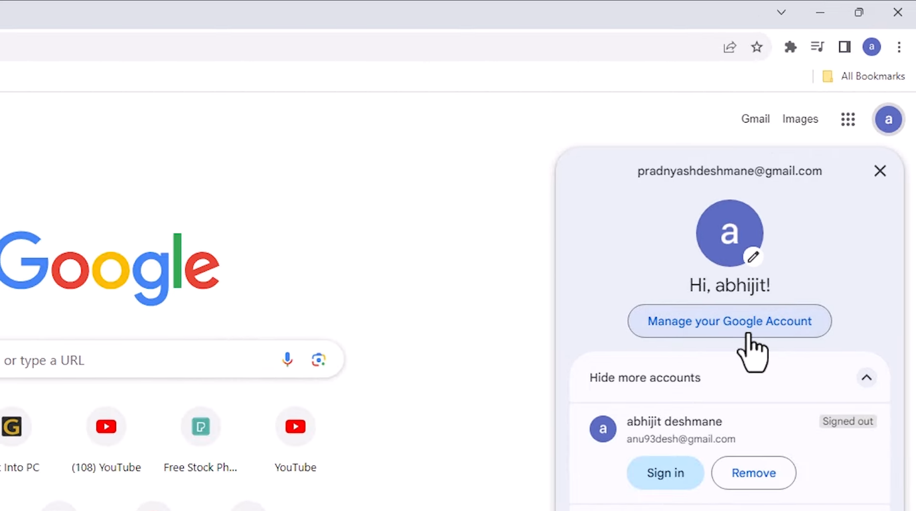

* + Navigate to Google Account Security.

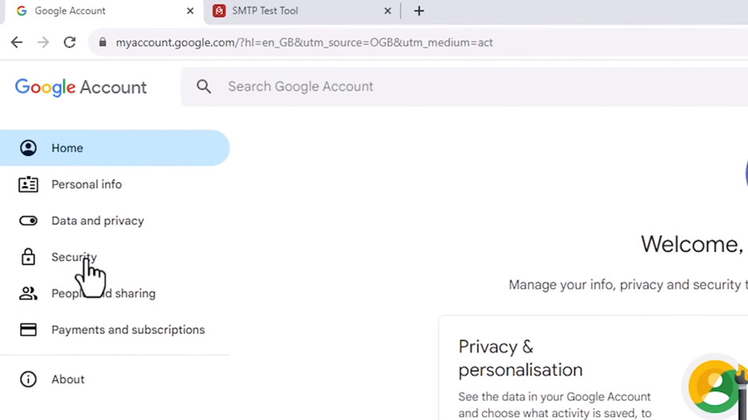

* + Under the “Signing in to Google” section, click on “2-Step Verification” and follow the instructions to enable it if not done previously.

1. **Create an App Password**:
   * In the Google Account Security page, click on “App passwords”.

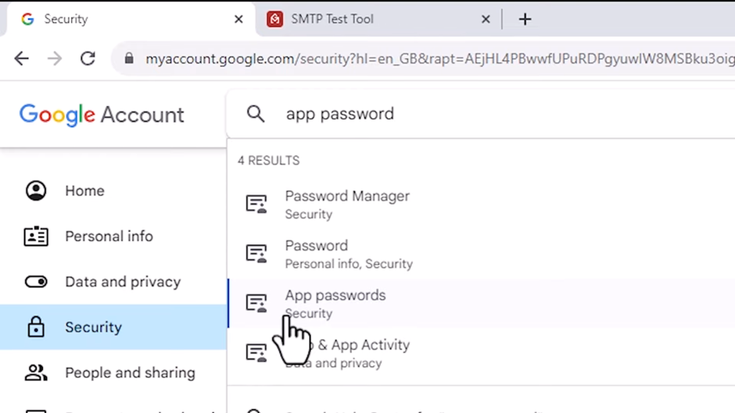

* + If prompted, enter your Google account password.
  + Under “App name put an unique name for the app.
  + Click “Create”.

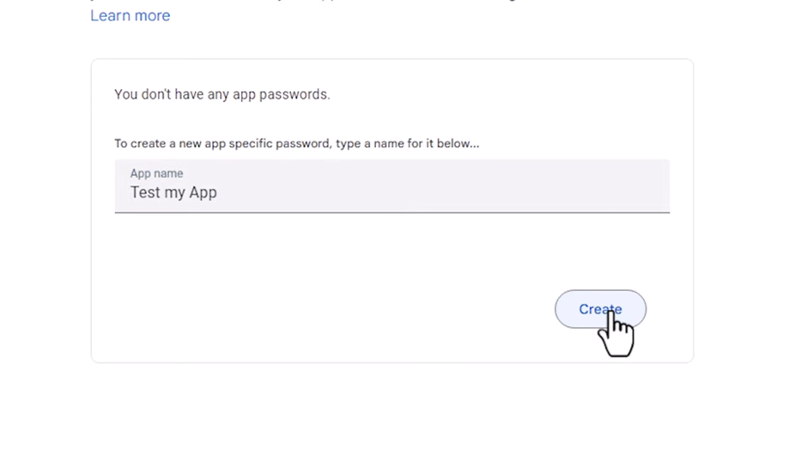

* + Copy the generated app password and save it securely. This password will be used instead of your regular Gmail password.

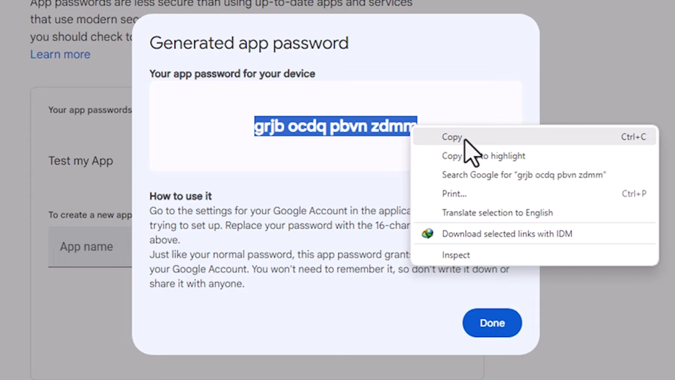

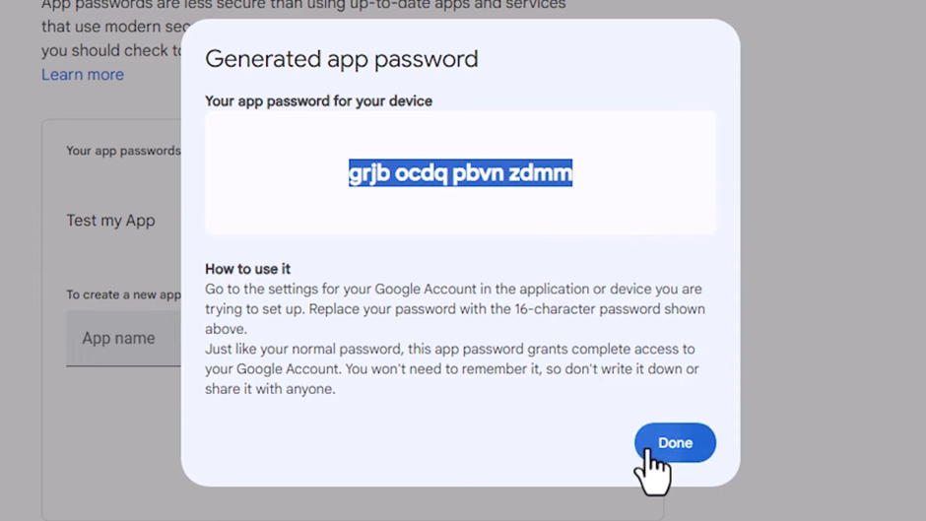

**2. Obtain SMTP Configuration Details**

The SMTP configuration details for Gmail are as follows:

* Go to <https://www.gmass.co/smtp-test> for testing the smtp server.
* **SMTP Server**: smtp.gmail.com
* **Port**: 465 (for SSL)
* **Security**: SSL
* **Username**: Your full Gmail email address (e.g., yourname@gmail.com)
* **Password**: The app password generated in the previous step
* **From email address**: Same as Username.
* **To email address**: Gmail address of the receiver (e.g., yourname@gmail.com)

1. Click on Test it.

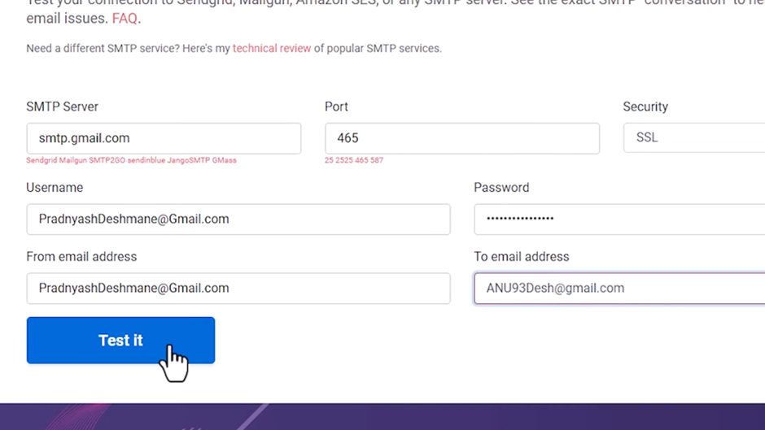

1. Verify if the mail is received at the receiver’s end.

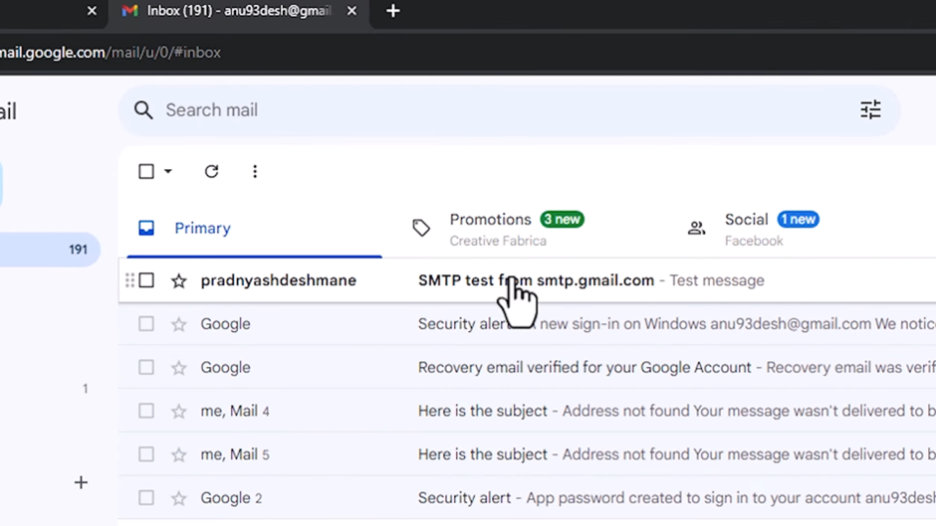

**Chapter 28: Configuring Default Email Settings in webMethods ActiveTransfer User Interface**

**Q1. Discuss the process of configuring default email settings in the webMethods ActiveTransfer user interface.**

**Steps to Configure Default Email Settings:**

1. **Access the Admin Console:**
   * Open the webMethods ActiveTransfer admin console and log in.
2. **Navigate to Default Email Settings:**
   * On the navigation pane, select Settings and then choose Default Email.
3. **Configure Email Templates:**
   * Define the templates for different types of emails (e.g., notification, alert, error):
     + **Subject:** Enter the default subject line for the emails.
     + **Body:** Specify the default body text for the emails. Use placeholders for dynamic content (e.g., {username}, {filename}).
4. **Set Default Recipients:**
   * Specify default recipients for the emails, such as administrators or support teams.
5. **Configure Attachment Settings:**
   * Define the rules for email attachments, such as maximum size and allowed file types.
6. **Save the Configuration:**
   * Click Save to apply the default email settings.

**Chapter 29: Configuring Default Email Settings in properties.cnf**

**Q29. Explain how to configure default email settings in properties.cnf for webMethods ActiveTransfer.**

Configuring default email settings in the properties.cnf file involves editing the configuration file directly.

**Steps to Configure Default Email Settings in properties.cnf:**

1. **Locate the properties.cnf File:**
   * Navigate to the directory where the properties.cnf file is located (typically within the Integration Server's config directory).

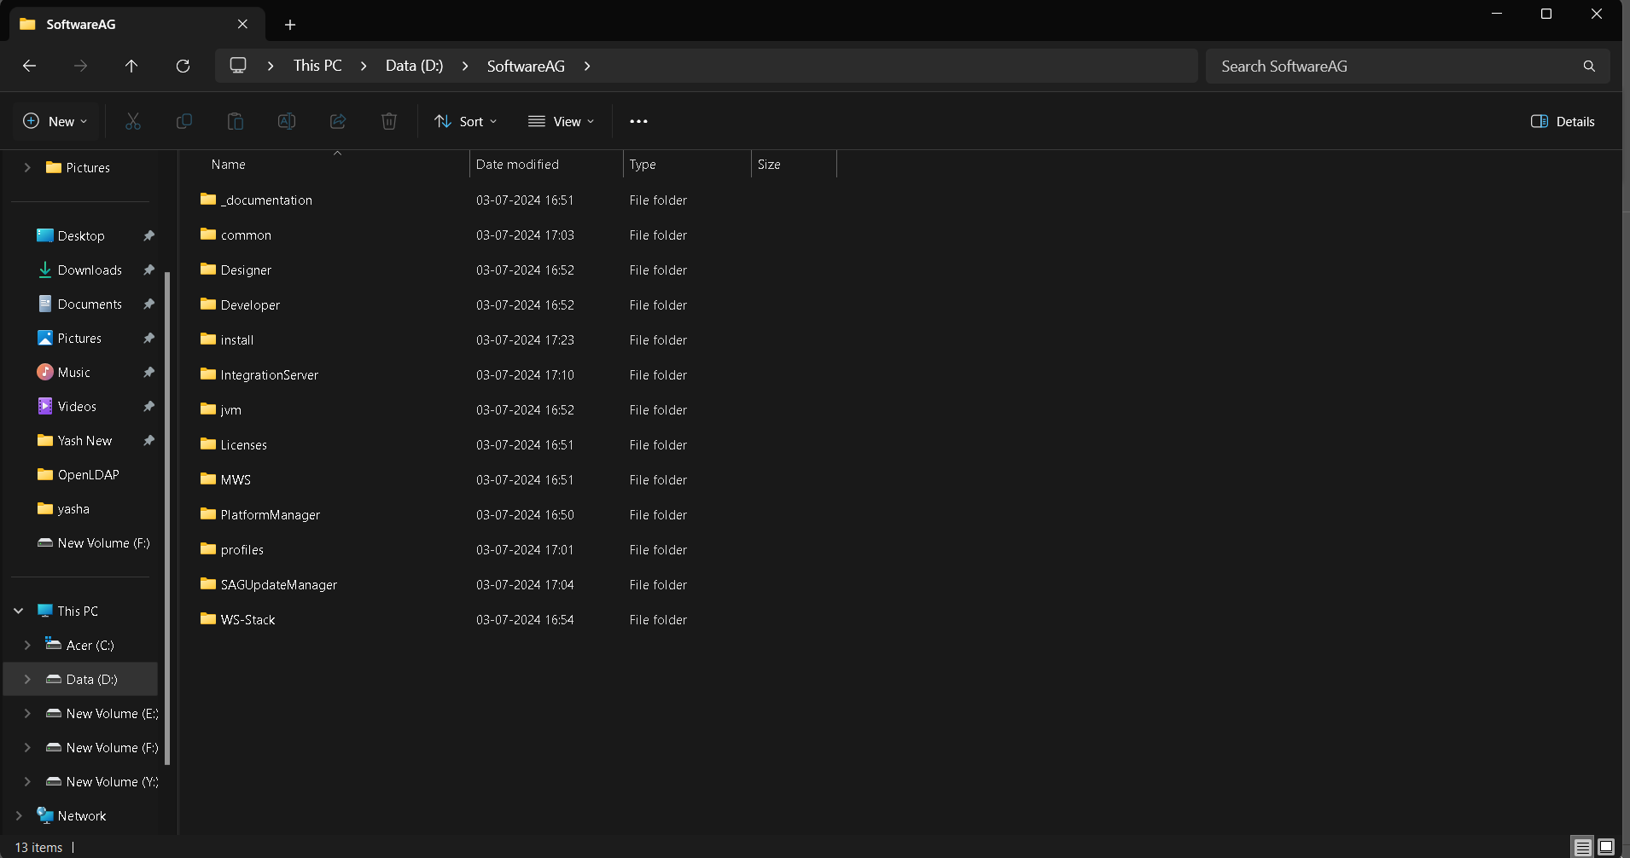

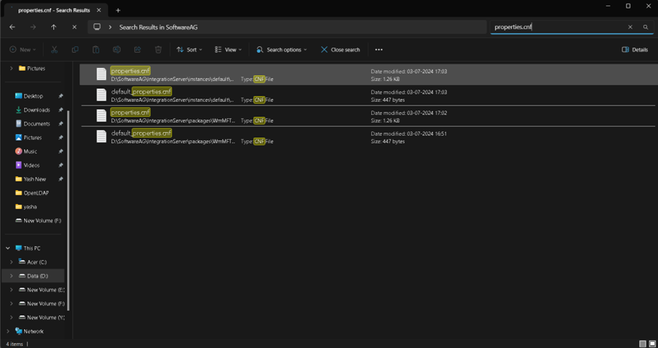

1. **Open the File:**
   * Open the properties.cnf file in a text editor.

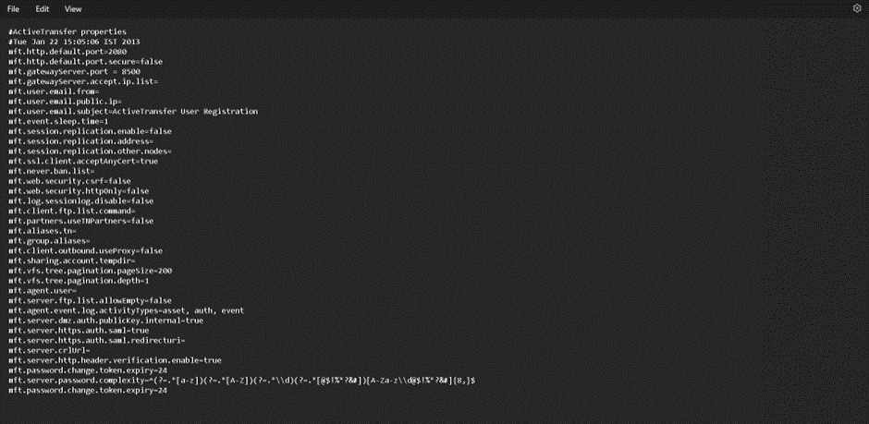

1. **Add or Edit Email Settings:**
   * Add or modify the following settings:
     + **mft.email.smtp.server:** The address of the SMTP server (e.g., smtp.example.com).
     + **mft.email.smtp.port:** The port number for the SMTP server.
     + **mft.email.from.address:** The default sender's email address.
     + **mft.email.replyto.address:** The default reply-to email address.
     + **mft.email.subject:** The default subject for email notifications.
     + **mft.email.body:** The default body text for email notifications.

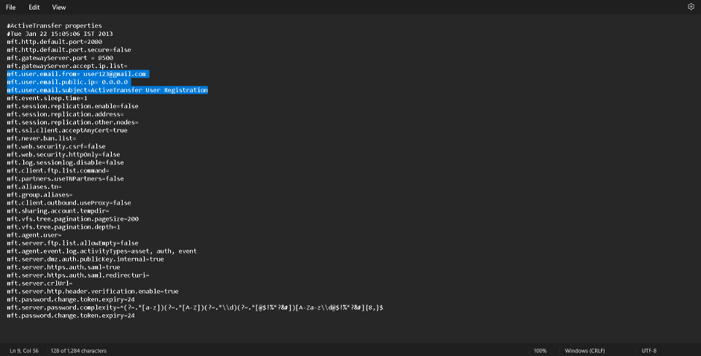

1. **Save the File:**
   * Save the changes to the properties.cnf file.
2. **Restart the Server:**
   * Restart the webMethods Integration Server to apply the changes.

**Chapter 30: Working with Services in webMethods ActiveTransfer**

**Q30. How can users work with services in webMethods ActiveTransfer?**

Users can work with services in webMethods ActiveTransfer to automate file transfers, integrate with other systems, and manage file-related processes.

**Steps to Work with Services:**

1. **Access the Admin Console:**
   * Open the webMethods ActiveTransfer admin console and log in.
2. **Navigate to Services:**
   * On the navigation pane, select Services.
3. **Create a New Service:**
   * Click the Add Service button.
   * Fill in the details for the service:
     + **Name:** Enter a unique name for the service.
     + **Description:** Provide a description of the service’s purpose.
4. **Configure Service Parameters:**
   * Define the parameters required for the service, such as:
     + **Source and Destination:** Specify the source and destination for file transfers.
     + **File Filters:** Set filters to include or exclude specific files based on criteria like file type or size.
5. **Define Service Actions:**
   * Add actions to be performed by the service:
     + **Transfer:** Set up file transfer actions (e.g., upload, download, move).
     + **Notification:** Configure email or system notifications for service events.
     + **Processing:** Add data processing steps, such as data transformation or validation.
6. **Schedule the Service:**
   * Set up a schedule for the service to run at specified times or intervals.
   * Use cron expressions for more complex scheduling needs.
7. **Save and Activate the Service:**
   * Click Save to store the service configuration.
   * Activate the service to start its execution based on the defined schedule.
8. **Monitor and Manage Services:**
   * Use the admin console to monitor service execution, review logs, and manage active services.

**Chapter 31: Document Types for Assets in webMethods ActiveTransfer**

**Q31. What are the different document types available for assets in webMethods ActiveTransfer?**

webMethods ActiveTransfer supports a variety of document types for managing assets, each designed to fulfill specific roles in file transfer and integration workflows. These document types ensure that users can handle diverse data formats efficiently and effectively.

**Types of Document Assets:**

1. **File**:
   * **Description**: Represents a single file, which can be any type of document, image, or data file. This is the most common type of asset used for straightforward file transfers.
   * **Examples**: Word documents, PDFs, JPEG images, text files, etc.
2. **Folder**:
   * **Description**: Represents a directory that contains multiple files and subfolders. This type is essential for organizing and managing collections of files.
   * **Examples**: Project folders, data directories, archival folders, etc.
3. **Virtual Folder**:
   * **Description**: A logical grouping of files and folders, not tied to a specific physical directory. Virtual folders help users manage and categorize assets without changing their actual locations.
   * **Examples**: Collections of files based on project phases, user-specific folders, etc.
4. **Metadata**:
   * **Description**: Custom metadata associated with files or folders, used for categorization, search, and enhanced file management. Metadata can include information like file type, creation date, author, and tags.
   * **Examples**: Tags for confidential files, author names for documents, creation dates for records, etc.
5. **Profile**:
   * **Description**: Configuration profiles for users, partners, or systems involved in file transfers. These profiles contain settings and preferences that streamline and secure the transfer process.
   * **Examples**: User profiles with access permissions, partner profiles with specific transfer protocols, system profiles with default configurations, etc.
6. **Script**:
   * **Description**: Scripts that automate tasks or processes within ActiveTransfer. These scripts can be used to perform repetitive tasks, handle complex workflows, or integrate with other systems.
   * **Examples**: Batch scripts for file processing, automation scripts for data conversion, integration scripts for external systems, etc.
7. **ZIP File**:
   * **Description**: A compressed file format that can contain multiple files and folders. ZIP files are used to bundle and compress assets for efficient storage and transfer.
   * **Examples**: Archived project files, compressed data backups, bundled software packages, etc.
8. **Binary File**:
   * **Description**: Represents non-text files that contain binary data. These files can be executable programs, images, videos, or any other type of data not easily represented as text.
   * **Examples**: Executable files (.exe), images (.png, .jpg), videos (.mp4), etc.
9. **XML File**:
   * **Description**: Extensible Markup Language files used for structured data representation and transfer. XML files are commonly used in data interchange between systems.
   * **Examples**: Configuration files, data export/import files, web service responses, etc.
   * .

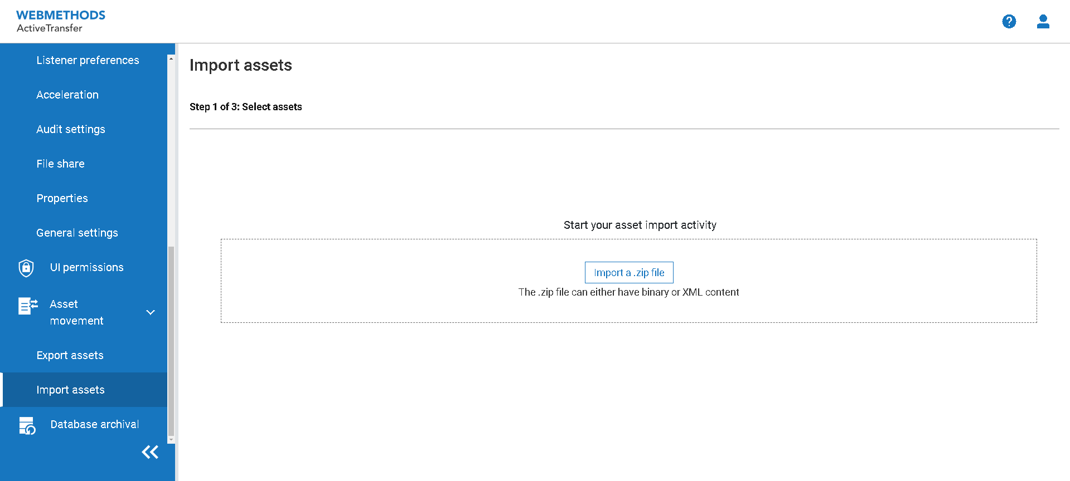

**Chapter 32: Searching for Archived Data in webMethods ActiveTransfer**

**Q32. How to Search for Archived Data in webMethods ActiveTransfer?**

Searching for archived data in webMethods ActiveTransfer involves using the system's built-in features to locate and retrieve archived logs, transaction records, and other historical data. This process is essential for audit purposes, troubleshooting, and maintaining compliance with data retention policies. Below are detailed steps and explanations on how to perform this task effectively.

**Step-by-Step Guide to Searching for Archived Data**

1. **Accessing the Archive Search Interface:**
   * Log in to the webMethods ActiveTransfer user interface.
   * Navigate to the **Administration** section, which typically includes various management and configuration options.
2. **Selecting the Archive Search Option:**
   * In the **Administration** section, look for an option labeled **Archive Search** or similar. This option allows you to access the interface dedicated to searching through archived data.
3. **Defining Search Criteria:**
   * **Date Range:** Specify the date range for the data you wish to search. This can help narrow down the results to a specific period.
   * **File Name:** Enter the name or partial name of the file you are looking for. Wildcards may be supported to help with partial matches.
   * **Transaction ID:** If you are searching for a specific transaction, you can enter its unique transaction ID.
   * **User:** Specify the user associated with the archived data if you are looking for data related to a particular user’s activities.
4. **Executing the Search:**
   * After defining your search criteria, click on the **Search** button. The system will process your request and display the results that match your criteria.
5. **Reviewing Search Results:**
   * The results will be displayed in a list format, showing relevant details such as file names, transaction IDs, dates, users, and statuses.
   * You can sort the results by clicking on column headers or use additional filters to refine the results further.
6. **Accessing Archived Data:**
   * Click on a specific result to view more details. Depending on the system’s capabilities, you might be able to:
     + **Download:** Retrieve the archived file or log for offline review.
     + **View:** Open the archived data directly within the user interface.
     + **Export:** Export the search results to a file format such as CSV or PDF for reporting or further analysis.
7. **Saving Search Queries:**
   * Some systems allow you to save your search criteria for future use. This can be useful if you perform similar searches regularly. Look for an option to save the search query within the search interface.

**Practical Example**

Suppose you need to search for all archived data related to user "JohnDoe" for the month of May 2023. Here’s how you would perform this search:

1. **Access the Archive Search Interface:**
   * Log in and navigate to **Administration > Archive Search**.
2. **Define Search Criteria:**
   * **Date Range:** Set the date range from "2023-05-01" to "2023-05-31".
   * **User:** Enter "JohnDoe".
3. **Execute the Search:**
   * Click on the **Search** button.
4. **Review Results:**
   * Examine the list of results. You might see entries like file transfers, logs, and transactions related to "JohnDoe".
5. **Access Data:**
   * Click on individual results to view details, download files, or export the list of results.

**Best Practices**

* **Regular Archiving:** Ensure that data is archived regularly as per your organization’s policies to facilitate efficient searches.
* **Use Descriptive Names:** Use descriptive file names and consistent naming conventions to make it easier to locate specific files.
* **Optimize Search Parameters:** Be as specific as possible with your search criteria to minimize the volume of results and quickly find the relevant data.

**Chapter 33: Disabling Email Alerts in webMethods ActiveTransfer**

**Q33. How Can Users Disable Email Alerts in webMethods ActiveTransfer?**

Disabling email alerts in webMethods ActiveTransfer can be necessary to prevent excessive notifications, manage system performance, or during maintenance periods. This process involves modifying the settings in the ActiveTransfer configuration to ensure that email alerts are not triggered.

**Step-by-Step Guide to Disabling Email Alerts**

1. **Accessing the ActiveTransfer User Interface:**
   * Open your web browser and log in to the webMethods ActiveTransfer Server user interface using your credentials.
2. **Navigating to Settings:**
   * Once logged in, navigate to the **Settings** section of the ActiveTransfer Server interface. This is typically found under the **Administration** or **Configuration** menu.
3. **Locating Email Notification Settings:**
   * In the settings menu, look for the **Email Notifications** or **Alerts** section. This section will contain the configuration options for email alerts.
4. **Disabling Email Alerts:**
   * Within the Email Notifications settings, you will find various options to configure which types of alerts are sent. To disable email alerts, uncheck or deselect the options for the types of alerts you want to disable. These might include:
     + **File Transfer Alerts:** Notifications for successful or failed file transfers.
     + **System Alerts:** Notifications for system errors or warnings.
     + **User Alerts:** Notifications for user activities or permissions.
5. **Saving Changes:**
   * After adjusting the settings to disable the desired email alerts, click the **Save** or **Apply** button to save your changes. This will update the configuration and disable the specified email notifications.
6. **Verifying the Configuration:**
   * To ensure that email alerts have been successfully disabled, you can perform a test action that would typically trigger an email alert (e.g., initiating a file transfer or causing a system event). Verify that no email notification is sent.

**Practical Example**

Suppose you want to disable all file transfer alerts and system alerts. Here’s how you would do it:

1. **Log in to the ActiveTransfer Interface:**
   * Open your browser and log in to the ActiveTransfer Server.
2. **Navigate to Settings:**
   * Go to the **Administration** or **Configuration** menu and select **Settings**.
3. **Access Email Notifications:**
   * Find and select the **Email Notifications** section.
4. **Alerts:**
   * Uncheck the boxes for **File Transfer Alerts** and **System Alerts**.
5. **Save Changes:**
   * Click **Save** to apply the new settings.
6. **Verify:**
   * Perform a file transfer or trigger a system event and check that no email alert is sent.

**Best Practices**

* **Selective Disabling:** If you do not want to disable all email alerts, carefully select which types of alerts to disable to ensure you still receive critical notifications.
* **Documentation:** Keep a record of any changes made to the email alert settings, including the date and reason for the change.
* **Monitoring:** After disabling email alerts, monitor the system closely to ensure that important events are still being tracked and addressed in other ways.
* **Periodic Review:** Regularly review the email alert settings to ensure they still meet the needs of your organization and adjust them as necessary.

**Chapter 34: Configuring Password Complexity for Users in webMethods ActiveTransfer**

**Q34. How Can Users Configure Password Complexity for Users in webMethods ActiveTransfer?**

Configuring password complexity is essential for enhancing security in webMethods ActiveTransfer. This involves setting rules that users must follow when creating or changing their passwords, ensuring that passwords are strong and difficult to guess.

**Step-by-Step Guide to Configuring Password Complexity**

1. **Accessing the ActiveTransfer User Interface:**
   * Open your web browser and log in to the webMethods ActiveTransfer Server user interface using your credentials.
2. **Navigating to Security Settings:**
   * Once logged in, navigate to the **Security** section of the ActiveTransfer Server interface. This section is typically found under the **Administration** or **Configuration** menu.
3. **Locating Password Policy Settings:**
   * In the security settings menu, look for the **Password Policy** or **Password Settings** section. This section will contain the configuration options for password complexity.
4. **Defining Password Complexity Rules:**
   * Within the Password Policy settings, you will find various options to configure password complexity rules. These rules might include:
     + **Minimum Length:** Set the minimum number of characters required for a password (e.g., 8 characters).
     + **Maximum Length:** Set the maximum number of characters allowed for a password.
     + **Character Requirements:** Specify the types of characters that must be included in a password, such as:
       - Uppercase letters (A-Z)
       - Lowercase letters (a-z)
       - Numbers (0-9)
       - Special characters (e.g., @, #, $, etc.)
     + **Password Expiry:** Define how often users must change their passwords (e.g., every 90 days).
     + **Password History:** Set the number of previous passwords that cannot be reused.
5. **Setting Up Additional Security Measures:**
   * Consider enabling additional security measures such as:
     + **Account Lockout:** Define the number of failed login attempts before an account is locked.
     + **Multi-Factor Authentication (MFA):** Require users to provide additional verification beyond just a password.
6. **Saving Changes:**
   * After configuring the password complexity rules, click the **Save** or **Apply** button to save your changes. This will update the security settings and enforce the new password policy.
7. **Communicating the New Policy to Users:**
   * Inform users about the new password complexity rules and provide guidelines on how to create strong passwords that comply with the new policy.

**Practical Example**

Suppose you want to enforce the following password complexity rules:

* Minimum length: 12 characters
* Must include at least one uppercase letter, one lowercase letter, one number, and one special character
* Password expiry: 60 days
* Password history: Last 5 passwords cannot be reused

Here’s how you would configure these settings:

1. **Log in to the ActiveTransfer Interface:**
   * Open your browser and log in to the ActiveTransfer Server.
2. **Navigate to Security Settings:**
   * Go to the **Administration** or **Configuration** menu and select **Security**.
3. **Access Password Policy:**
   * Find and select the **Password Policy** section.
4. **Set Complexity Rules:**
   * Set the minimum length to 12 characters.
   * Require at least one uppercase letter, one lowercase letter, one number, and one special character.
   * Set the password expiry to 60 days.
   * Set the password history to 5 passwords.
5. **Save Changes:**
   * Click **Save** to apply the new settings.
6. **Communicate with Users:**
   * Send an email or internal memo to users explaining the new password policy and providing tips for creating strong passwords.

**Best Practices**

* **Comprehensive Communication:** Ensure all users are aware of the new password policy and understand how to create passwords that comply with the rules.
* **User Training:** Provide training or resources to help users understand the importance of password security and how to create strong passwords.
* **Regular Review:** Periodically review and update the password policy to ensure it meets current security standards and best practices.
* **Balance Security and Usability:** While enforcing strong password rules is important, also consider the user experience to avoid overly complex requirements that might lead to poor password practices.

**Chapter 35: Configuring Email Notifications in webMethods ActiveTransfer**

In this chapter, we will explore how to configure webMethods ActiveTransfer to send email notifications. This functionality is useful for various scenarios such as post-processing actions, user creation, profile modification, and manual file sharing. We'll cover configuring the SMTP server and setting up default email settings.

**Prerequisites**

* Administrative access to webMethods Integration Server Administrator.
* Details of your SMTP server (address, port, authentication details).

**Overview**

webMethods ActiveTransfer can send emails in the following situations:

* As a post-processing action when a file is uploaded, downloaded, or deleted.
* When a new user is created.
* When an existing user profile is modified.
* When a user shares a file manually using the web client.

To enable this functionality, you need to configure the SMTP server and default email settings.

**Step-by-Step Guide**

**Step 1: Accessing SMTP Settings**

1. **Log in to Integration Server Administrator**
   * Open your web browser and navigate to the URL of your Integration Server Administrator.
   * Enter your credentials and log in.
2. **Navigate to Resources Settings**
   * In the left-hand menu, go to **Settings** > **Resources**.

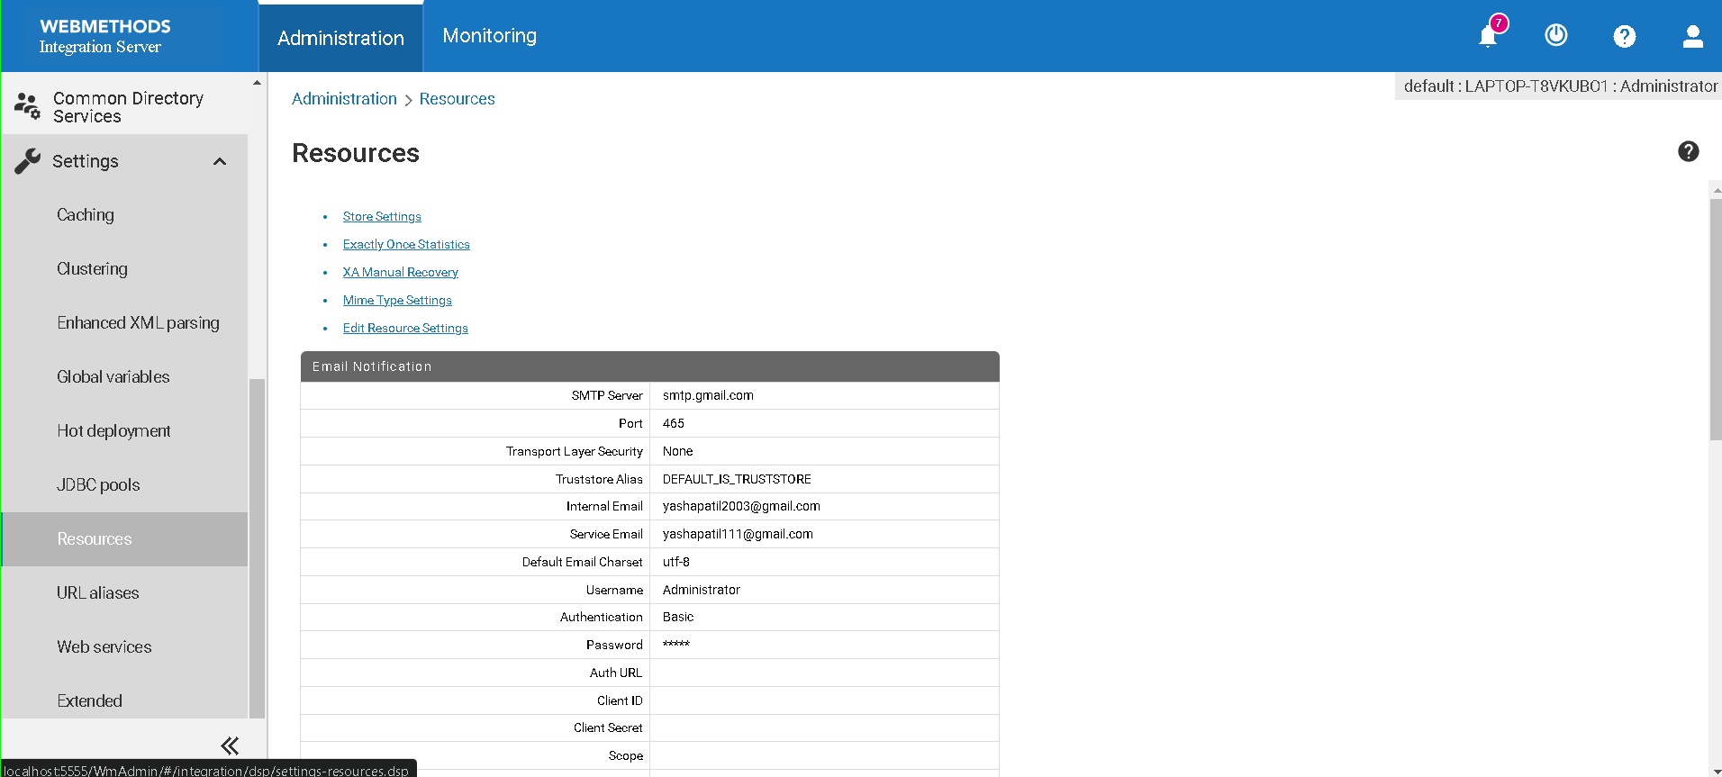

**Step 2: Configuring the SMTP Server**

1. **SMTP Server**: Enter the address of your SMTP server (e.g., smtp.example.com).
2. **Port**: Enter the port number your SMTP server uses. Common ports are:
   * 25 for standard SMTP.
   * 465 for SMTP over SSL.
   * 587 for SMTP over TLS.
3. **Transport Layer Security**: Select the appropriate security protocol:
   * **None**: If no encryption is required.
   * **SSL/TLS**: For secure connections initiated with SSL/TLS.
   * **STARTTLS**: For upgrading an existing insecure connection to a secure one.
4. **Truststore Alias**: Choose the truststore alias, typically DEFAULT_IS_TRUSTSTORE, unless you have a custom truststore.

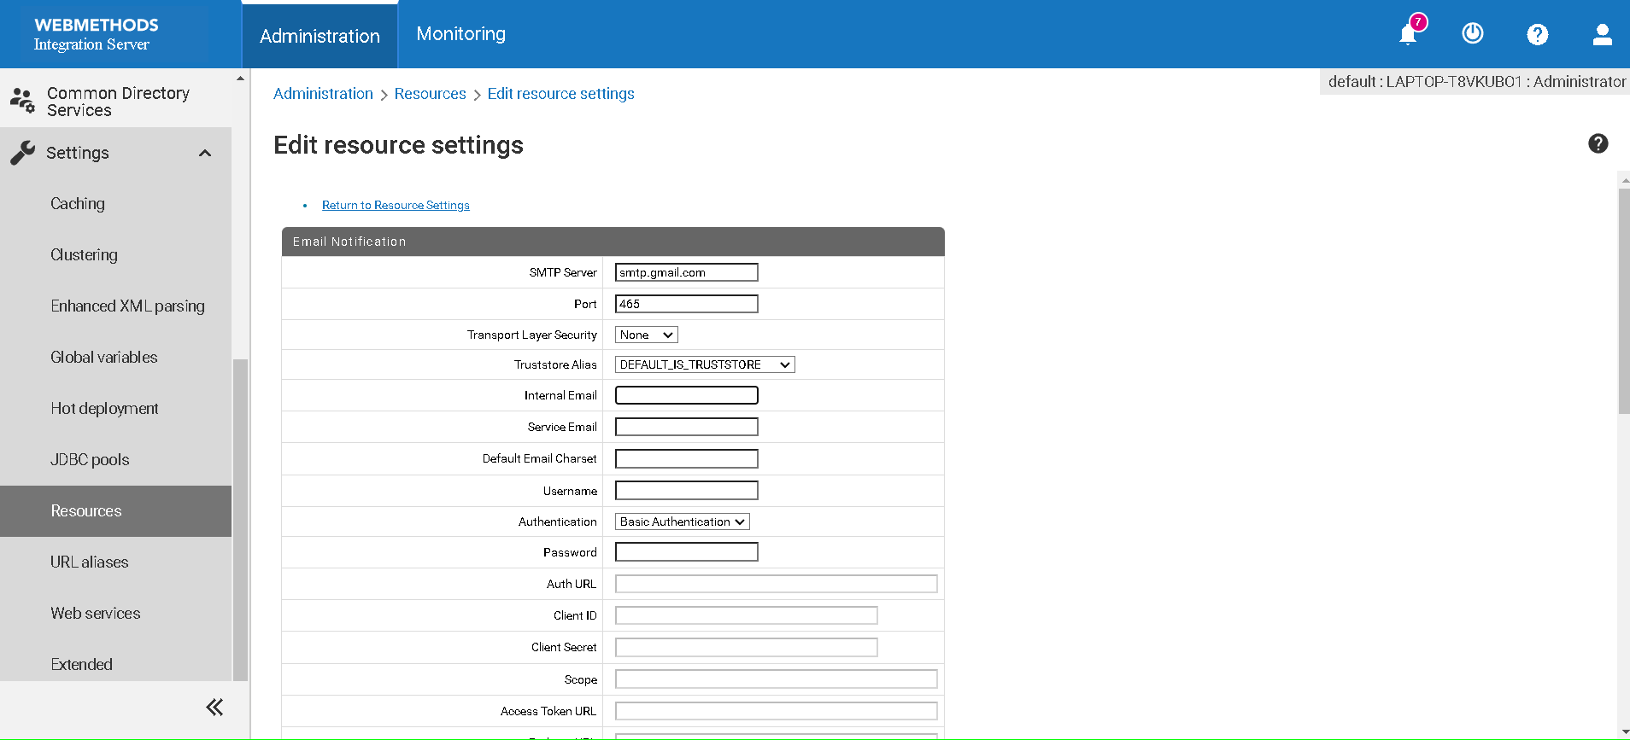

**Step 3: Configuring Authentication (If required)**

1. **Username**: Enter the username for your SMTP server.
2. **Password**: Enter the password for your SMTP server.
3. **Authentication**: Select the authentication method:
   * **Basic Authentication**: Commonly used if your SMTP server requires it.

**Step 4: Configuring Default Email Settings**

1. **Internal Email**: Set the default sender email address for internal emails (e.g., internal@example.com).
2. **Service Email**: Set the default sender email address for service-related emails (e.g., service@example.com).
3. **Default Email Charset**: Set the default character set, typically utf-8.

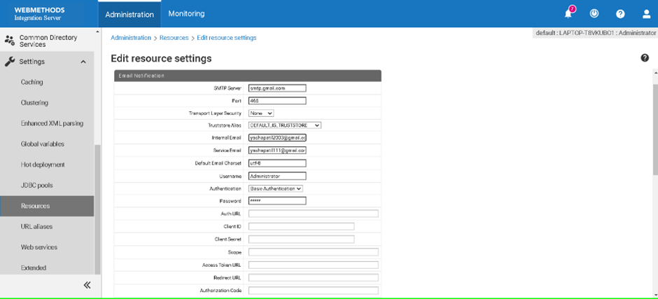

**Step 5: Saving the Configuration**

* After entering all the necessary details, click the appropriate save button to save the configuration.

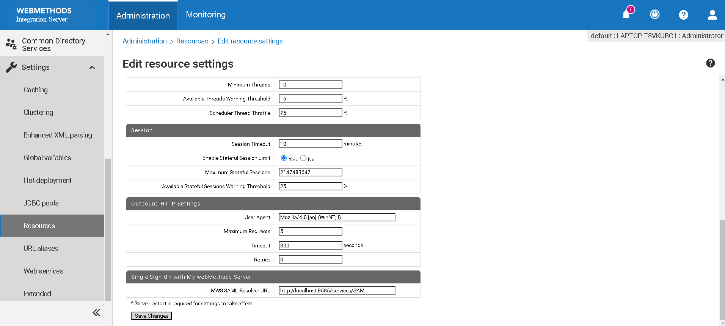

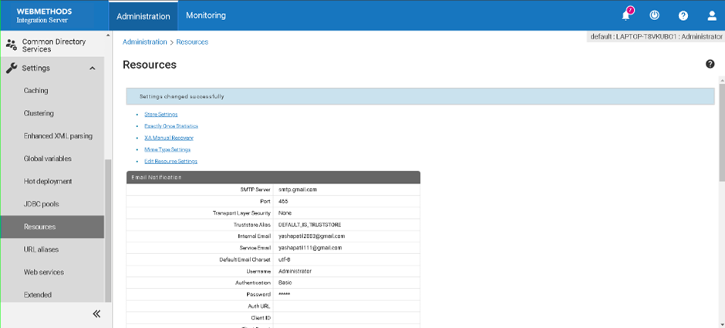

**Step 6: Testing the Configuration**

1. **Trigger an Email Event**: Test the configuration by triggering an event that sends an email, such as uploading a file.
2. **Verify Delivery**: Check if the email was received successfully.

**Troubleshooting**

**Emails Not Sent**

* **Check Logs**: Review the server logs for any error messages.
* **Verify SMTP Settings**: Ensure the SMTP server address, port, and credentials are correct.

**Connection Issues**

* **Port and Security Settings**: Confirm that the port number and transport layer security settings match those required by your SMTP server.

**Authentication Errors**

* **Credentials**: Ensure the username and password are correctly entered.
* **Supported Authentication Method**: Verify that your SMTP server supports the chosen authentication method.